Editor Autor: Stefan Czech | Photo Foto: Stefan Hanke | Location Ort: Wachtberg | Date Datum: Dez-20

An indispensable help at the composting plant: Wachtberg Kompost in North Rhine-Westphalia relies on the 355 E telehandler from SENNEBOGEN

Sorting, stacking, transporting material, loading trucks, quick journeys from A to B within confined space conditions and keeping an overview at the same time: At the composting plant in Wachtberg there are many different tasks to be done. For this you need a true multi-talent machine. SENNEBOGEN offers exactly that and Mr. Riebau, owner of Wachtberg Kompost, is more than satisfied with his decision.

The North Rhine-Westphalian community of Wachtberg is located in the middle of a volcanic shaped hill landscape. With its idyllic forests, castles and half-timbered houses, Wachtberg is a popular destination for many residents of the nearby federal city of Bonn. To ensure that this continues to be the case, the forests, gardens and parks of the community bordering on the Rhineland-Palatinate are constantly maintained. In the process, large quantities of so-called green residues accumulate, such as branches and shrubs. An extremely valuable resource for Klaus Riebau. Since 1993, the owner of Wachtberg Kompost and his employees have been processing green residues into high-quality compost, plant soil and bark mulch. To ensure that the sorting and loading of the material will be even more efficient in the future, the decision was made in favor of a 355 E telehandler from SENNEBOGEN, supplied by sales and service partner Jungbluth Baumaschinen GmbH.

Compact and maneuverable - ideal for composting plants
For the delivery of small quantities of green residues Wachtberg Kompost provides the customer with a trailer on loan, for large orders the material is picked up directly from the customer by truck. Once the material has been delivered to the composting plant, the SENNEBOGEN telescopic loader 355 E takes over the sorting work and, with a fully loaded hold-down shovel, winds its way through the huge and closely packed mountains of sorted green waste, root woods and other untreated garden waste. This is where the all-wheel steering system comes into play. This reduces the turning radius of the machine to less than 4 m and thus ensures a smooth ride from A to B.

Everything in view thanks to the telehandler’s elevating cab
Meanwhile, at the composting site, a shredder is used to chop bark into bark mulch. Loading the shredder with raw material is done efficiently thanks to the elevating cab of the 355 E telehandler. At 4.25 m eye level, the driver has an excellent view into the shredder's loading opening and can thus load material precisely and prevent possible blockages. Even when loading the trucks with finished bark mulch or compost soil, the clear view into the loading area offers several advantages. On the one hand, the flat viewing angle on or into the truck is neck-friendly for the driver and supports ergonomic working in the long term. On the other hand, the driver can see what he is doing and can, for example, improve the distribution of the material inside the truck container. Mr. Riebau, owner of Wachtberg Kompost, adds: "For us, the 355 E is a multi-talent, which simplifies the processing of green residues as well as material handling and loading considerably. Above all, the elevating cab gives us a constant overview of the site and also of the trucks. Thus the 355 E has become indispensable for us".

Stacking or loading material - both can be done quickly
The finished bark mulch must then be stacked very high. This is easy with the SENNEBOGEN 355 E telehandler. The clever combination of telescopic handler and wheel loader is also ideally equipped for this requirement. The robust steel construction of the telescopic boom with a stacking height of 8.5 m, the ideal power transmission into the bucket using the cleverly engineered Z-kinematics and the powerful drive train with continuously variable travel drive provide the driver with the perfect working conditions. Even heavily compacted and heavy compost is extracted effortlessly from the dense piles thanks to the high breakaway force of up to 85 kN. The innovative control of the drive unit automatically provides the driver with an optimum mix of pull/thrust force and travel speed - depending on the requirements.

The focus is on the customer's wishes - in individual equipment and service
The 355 E has been equipped with the Volvo quick-change system on request, an additional hydraulic circuit on the boom head and a permanent function for the standard auxiliary hydraulics. This means that demanding and already existing attachments can continue to be used. The permanent function for the auxiliary hydraulics with freely definable oil quantity is particularly useful when using the sweeper.

Klaus Riebau is clearly enthusiastic about his new all-rounder and also praises the comprehensive on-site service and technical support provided by SENNEBOGEN.
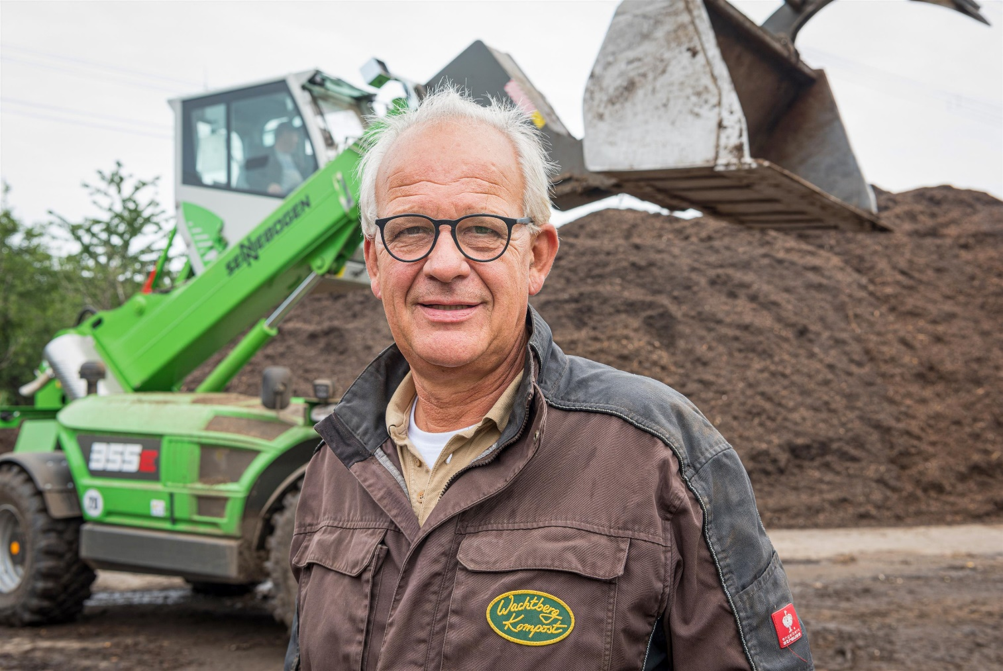
For Klaus Riebau, owner of Wachtberg Kompost, the 355 E telehandler from SENNEBOGEN is a true all-rounder.

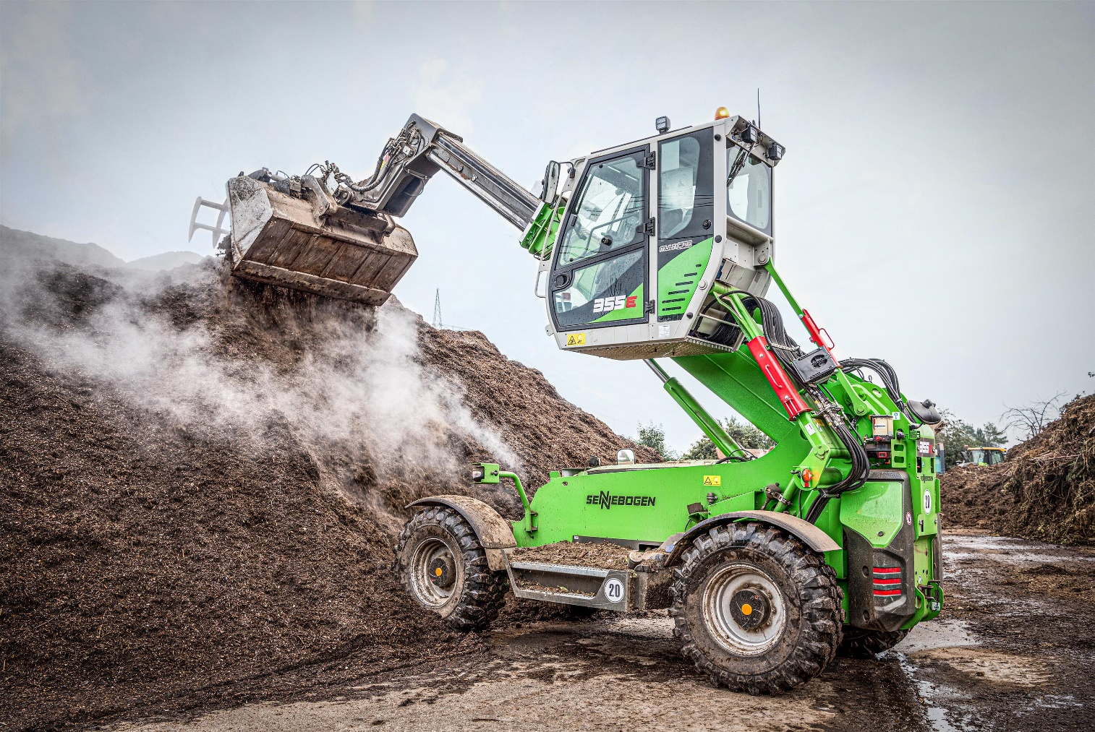
The SENNEBOGEN 355 E telehandler makes it easy to stack up high layers of bark mulch.

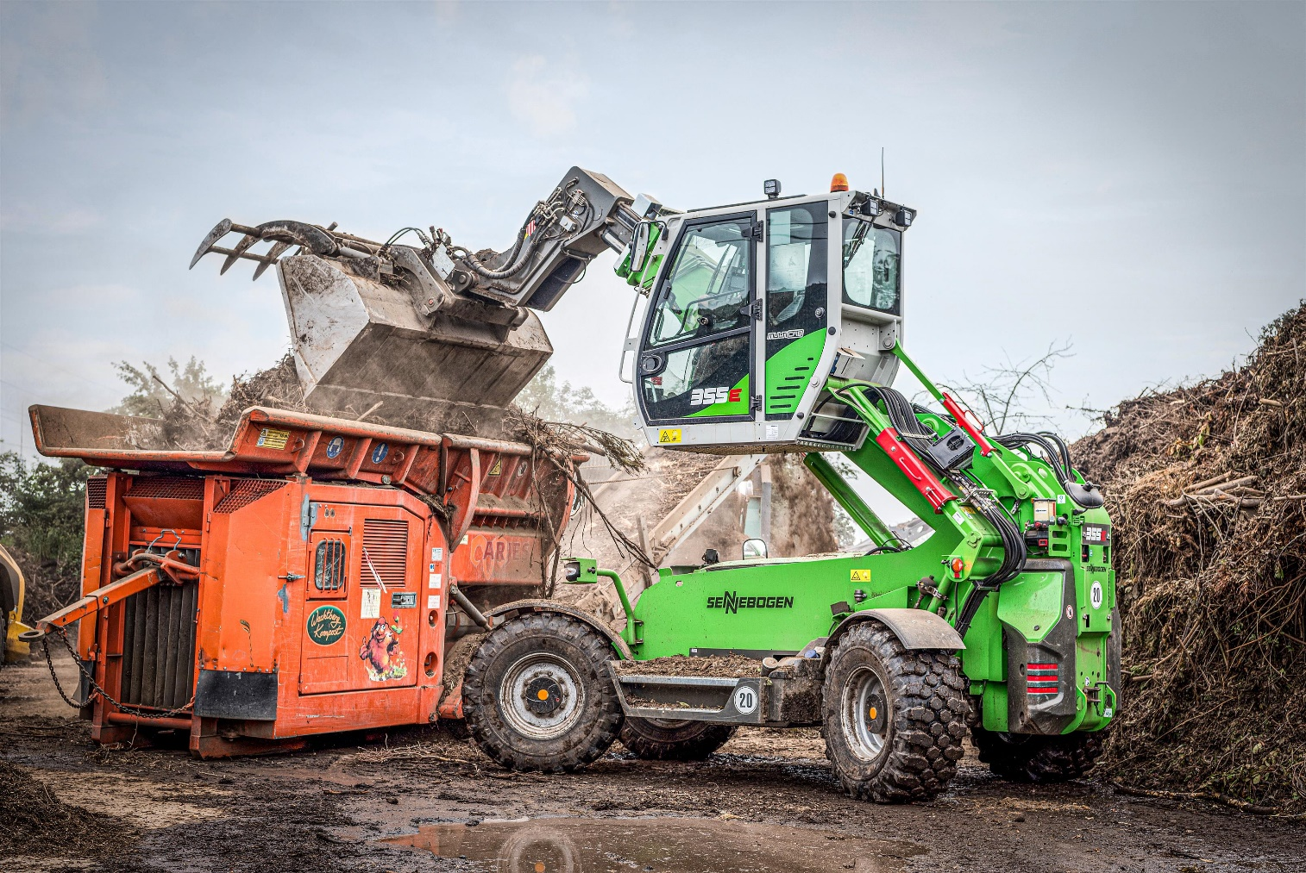
The telescopic loader 355 E offers an excellent view into the shredder's loading opening thanks to the elevating cab.

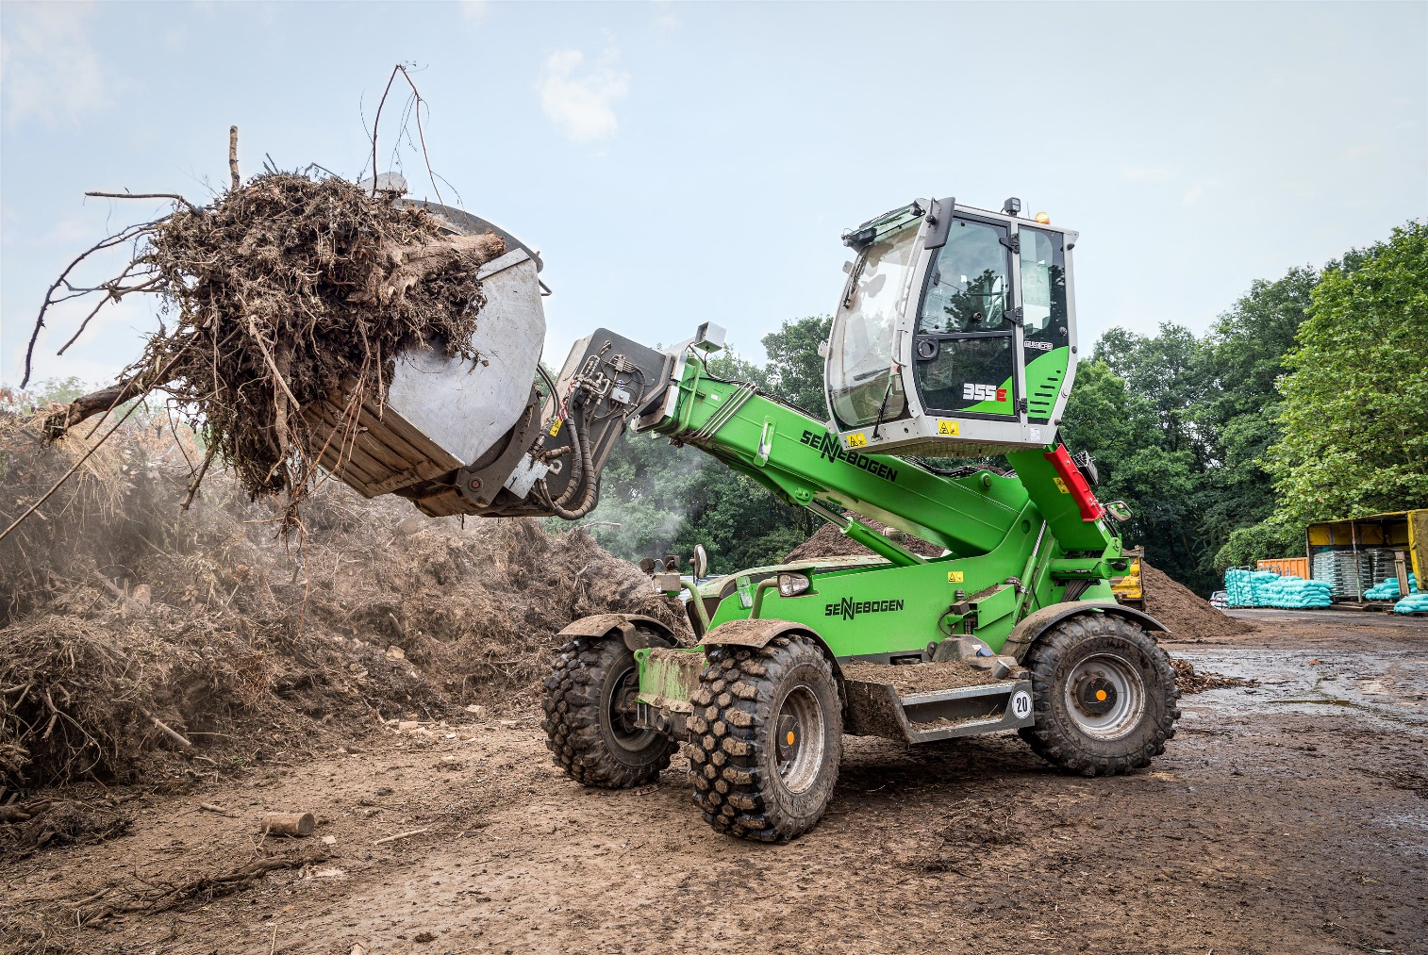
During sorting work, the SENNEBOGEN telehandler with a fully loaded hold-down shovel winds its way through the confined space conditions at the composting plant

