Bild:
Location: Wilburgstetten, DE
Photo Foto: SENNEBOGEN
Editor Autor: Sandra Hartl
Date Datum: 06/2021

Four material handlers take over log transport at Rettenmeier Wilburgstetten

A greenfield project to be proud of: Rettenmeier, one of the largest manufacturers of DIY wood products, started construction of a new sawmill at the Wilburgstetten site in spring 2020. Now, the commissioning of a new high-performance sawing line with three gradings and the expansion of the fleet by four new SENNEBOGEN timber handlers at the Wilburgstetten site has taken place. In this way, the processing capacity of the plant is to increase to a further 1.3 million FM per year in the future.
Whether sawn or structural timber, glulam or beams, Rettenmeier's product range is broad. "You can actually find us in just about every European construction market," explains plant manager Detlef Keuper. For log transport at the site, Keuper has relied on the good, long-standing cooperation with SENNEBOGEN and its sales and service partner Schlüter Baumaschinen GmbH for more than 15 years now: "We've been relying on the robust and powerful SENNEBOGEN material handlers for a long time now and are very satisfied with the reliability of the machines." The long service life of the machines is reflected in the considerable number of operating hours: up to 38,000 hours have already been achieved by a 730 E built in 2007 and is now used as a test vehicle for new employees. "We take great care of our fleet and achieve an impressive longevity of our machines thanks to very good maintenance and service“, emphasizes Detlef Keuper.
Log sorting: 730 E material handlers for log removal at the sorting boxes
In addition to the expansion with an additional sawing line, the sorting line will also be supplemented with additional boxes in the near future so that log lengths of up to 6.20 m can be sorted. Log removal and stacking of the logs up to a pile height of around 7 m is handled by two new SENNEBOGEN 730 E timber handlers, which are equipped with a powerful 168 kW diesel engine. Eduard Becker is one of a total of 17 drivers at the site and has been driving SENNEBOGEN material handlers since 2007: "You can tell that the SENNEBOGEN machines are constantly being developed. With my new 730 E, I particularly like the automatic travel and steering direction changeover. That makes work much easier. The joysticks are very well adapted to the needs of the driver.“
Truck unloading and feeding the sawing line by 735 E including 30 t trailer
Two SENNEBOGEN Pick & Carry machines 735 E are used for unloading the trucks and feeding the new sawing line. With the help of a timber grapple with integrated leaf chain, the logs are loaded onto the company's own trailer and then transported to the new sawing line. Up to 30 tons can be transported at the same time. Particularly helpful here is that the SENNEBOGEN 735 E has a low rear ballast and thus a small turning radius due to its design. Here, too, the automatic steering and driving direction changeover proves to be a valuable helper. In between the narrow wood stacks, it is thus possible to drive easily and in a space-saving manner without time-consuming maneuvering, even with a trailer. This saves the company valuable time during operation.

[Caption:]
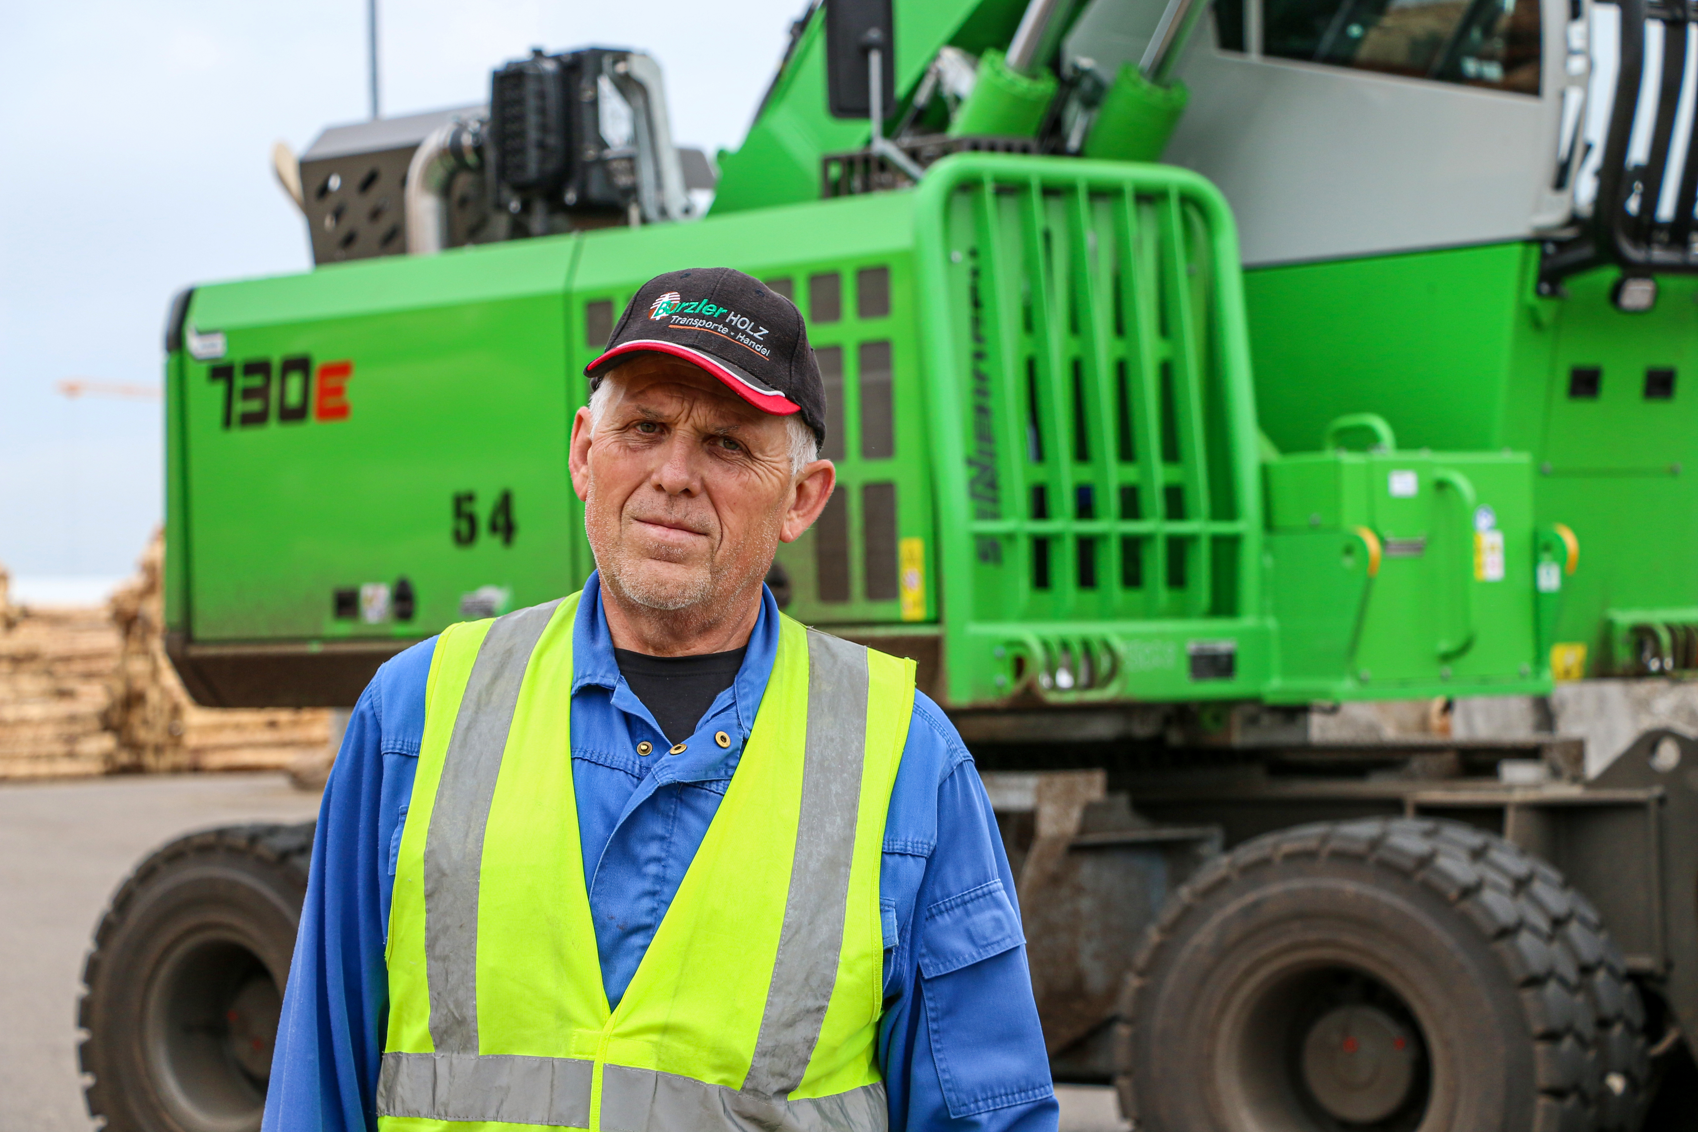
Eduard Becker, SENNEBOGEN operator since 2007, is enthusiastic about his new 730 E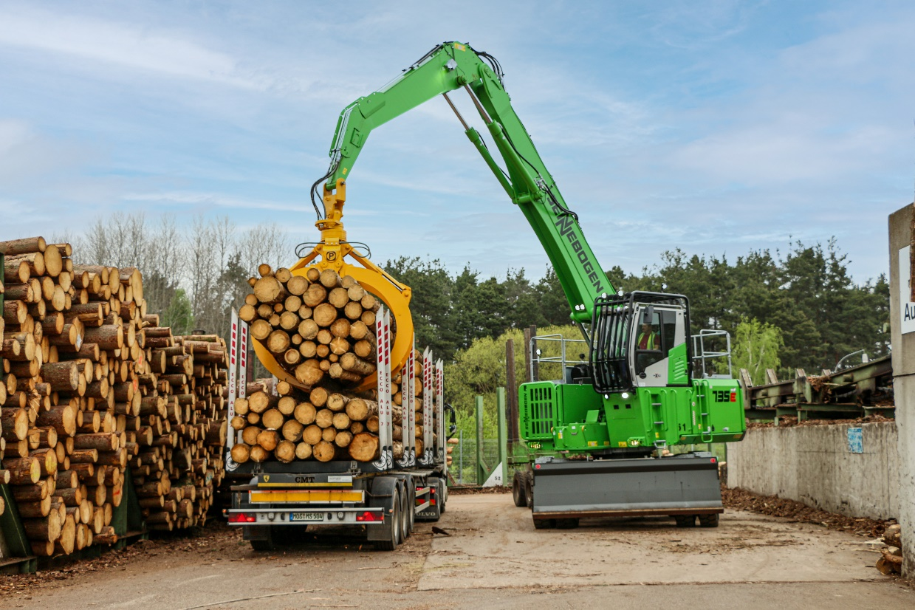
735 E with timber grapple including integrated leaf chain when unloading a truck trailer
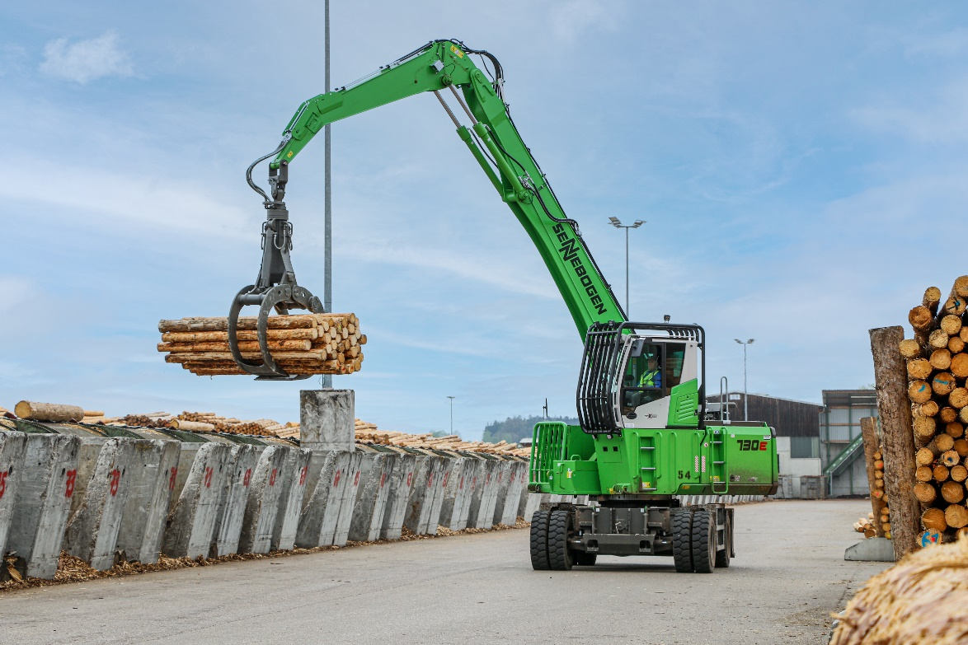
Two new 730 E take over the log removal at the sorting boxes
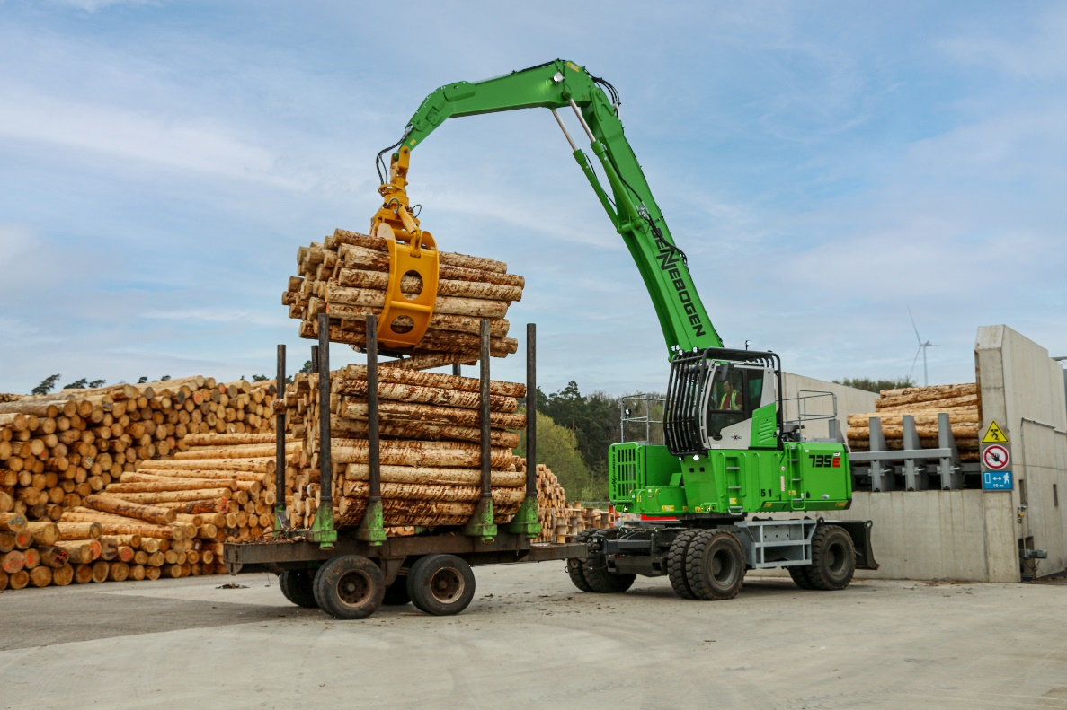
735 E with 30-ton trailer feeds the new sawing line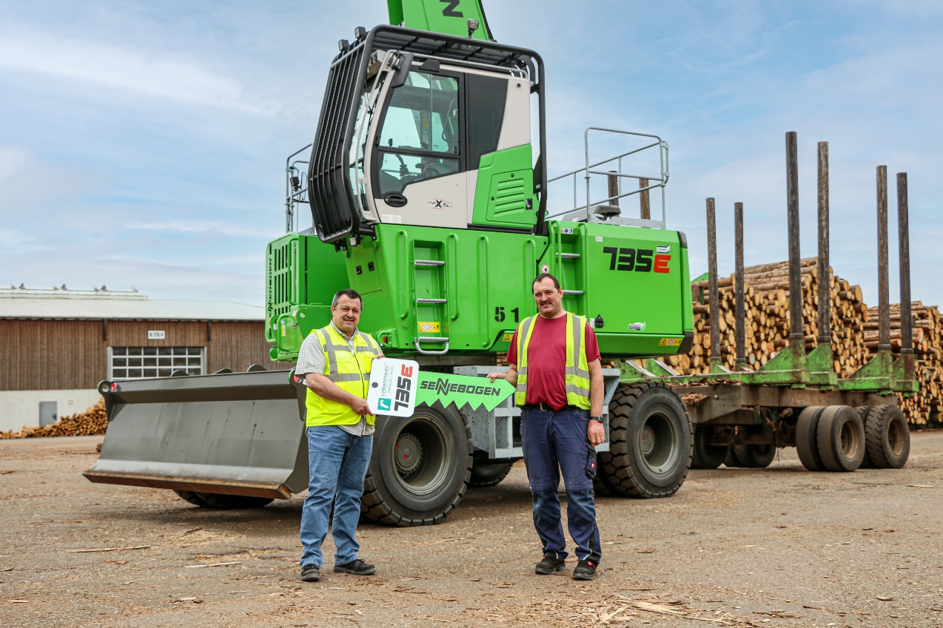
Plant manager Detlef Keuper handing over a new 735 E with trailer to experienced machine operator Edwin Pflanz

