Bild:
Location Ort: Straubing, Germany
Photo Foto: German Popp
Editor Autor: Kerstin Wabner
Date Datum: 04.02.2020

Straight from the plant to the job: demolition company Brandhuber relies on SENNEBOGEN 830 demolition in selective dismantling
It was probably one of the shortest machine transports in the entire history of SENNEBOGEN: Only about two kilometers away from the headquarters of the company, Manfred Brandhuber, Managing Director of Brandhuber Transporte GmbH, started a major deconstruction project in the historic city center of Straubing's ducal city last December. On the 2,000 sqm site, three buildings were selectively dismantled over a period of 4 weeks – the perfect conditions for the SENNEBOGEN 830 E with 168 kW engine power to unfold its full potential as a multifunctional demolition machine: Stable working in 360° mode, effortless stripping of the up to four-story former residential buildings and immediate sorting of the construction debris into the allocated containers.

It was one of those cold December evenings that you spend on the couch with Pre-Christmas joy, cookies, tea and a warm blanket. But while some people are at home enjoying their well-earned evening off, the hard work of others begins: On the company premises of the SENNEBOGEN subsidiary with its Rental & Used department, transport professionals load heavy equipment onto the low-loader, lash the chains and the approximately two-kilometer drive of the SENNEBOGEN 830 Demolition to the city center of Straubing begins: straight from the plant to the job.

Over the past weeks, the 45 t demolition machine from the SENNEBOGEN rental park created space for new office and residential units in the city center. Around the area of operation and within reach of the 830 Demolition, deconstruction professional Manfred Brandhuber arranges different rubble containers in order to conveniently fill them with the material without repositioning the machine: "For us, selective dismantling means removing material in a controlled and safe manner. Normally, we rely on earthmoving equipment, but it simply didn't offer us the necessary reach height for this job. Since SENNEBOGEN is located virtually around the corner, the 830 Demolition was available very quickly and we were able to expand our fleet easily with the rental offer."

SENNEBOGEN 830 demolition machine is flexible, stable and ergonomically designed
Demolition grab, shears, bucket, hammer: thanks to the powerful hydraulics of the demolition machine, the operation of different attachments requiring high pressures is possible. With the quick coupler on the stick, the 830 Demolition also adjusts to a new task in no time. It is the central player on the Straubing construction site and scores with its precision, its user-friendly joystick controls and the design focused on the needs of the operator: "The elevating and tilting cab is really a practical feature for leaning back in the seat close to the work area when removing the material. That' s good for my neck, because I can work in a natural posture and at the same time enjoy a clear view of my attachment," Brandhuber comments on his experience with the machine.

The 4.5 m wide, telescopic undercarriage in particular is responsible for the stability of the demolition machine. It ensures that the compact 45-ton machine remains stable at all times, even when the upper carriage is rotated quickly and heavy loads are in the grab. Brandhuber himself demonstrates on site what the 830 E is capable of: "In our operation today, the roof of the building is being removed. We first grab the chimney at a height of 15 m, move it to the ground in one piece, disassemble all other components of the roof there and immediately load bricks, metals or wood into the various containers for subsequent recycling."

Efficiency is a question of strategic demolition equipment deployment
Both the stability and the ability to work in 360° mode are crucial for Brandhuber, the demolition contractor, because the endless upper carriage rotation eliminates all time-consuming maneuvers for repositioning the machine. In a worst case scenario, the ground would have to be specially prepared and stabilized at the machine's new location, which would take up further valuable time. So the better the construction steps are planned in advance, coupled with well thought-out positioning of the demolition machine on site, the more time and money can be saved.

Brandhuber adds that it is strategically valuable that he has rented the SENNEBOGEN 830 E directly from the manufacturer and works in the immediate vicinity of the plant: "Fast support is important to me, as I depend on the functionality of the equipment on the construction site. That's why I really appreciate the personal contact with SENNEBOGEN and the resulting short lines of communication."

[Caption:]
Together, Manfred Brandhuber, Managing Director of Brandhuber Transporte GmbH (right), and Alexander Sturm, Sales Manager at SENNEBOGEN Vertriebsgesellschaft (left), planned the deployment of the SENNEBOGEN 830 demolition machine in Straubing, Germany.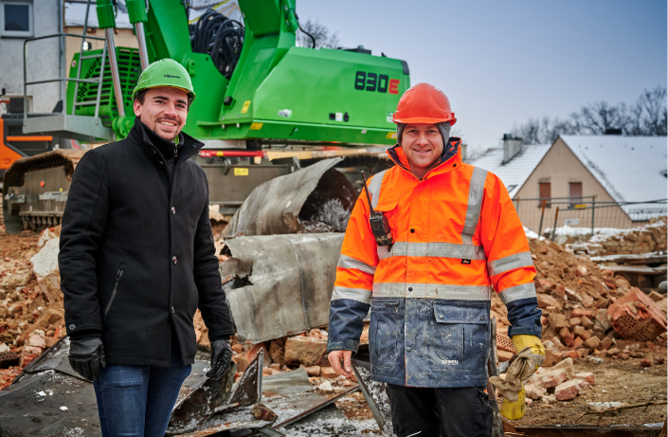

SENNEBOGEN 830 demolition machine in 360° mode: gripping, removing, crushing, sorting into containers – all this is possible without repositioning the machine.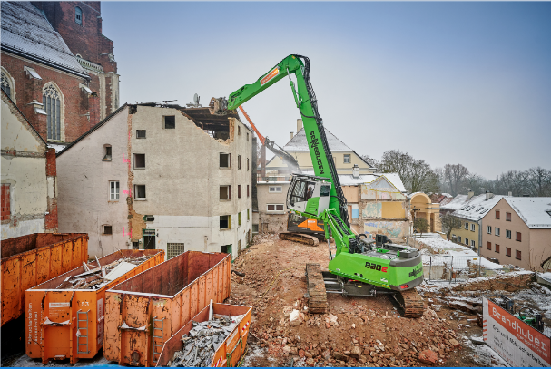
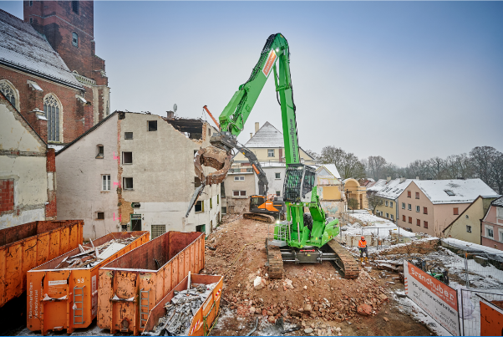
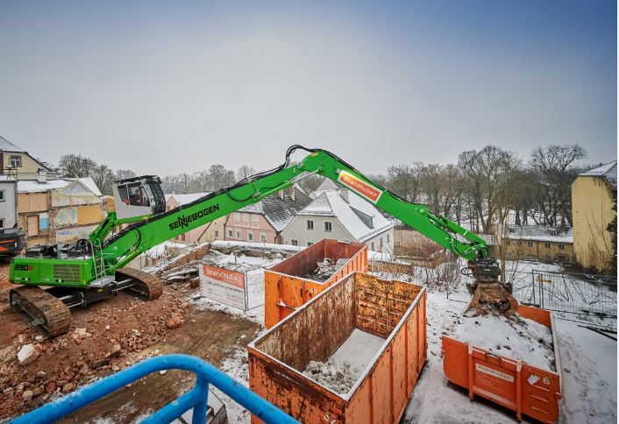

SENNEBOGEN 830 demolition: The 45-ton machine with a 4.5 m wide, telescopic undercarriage proves its stability during demolition in Straubing's city center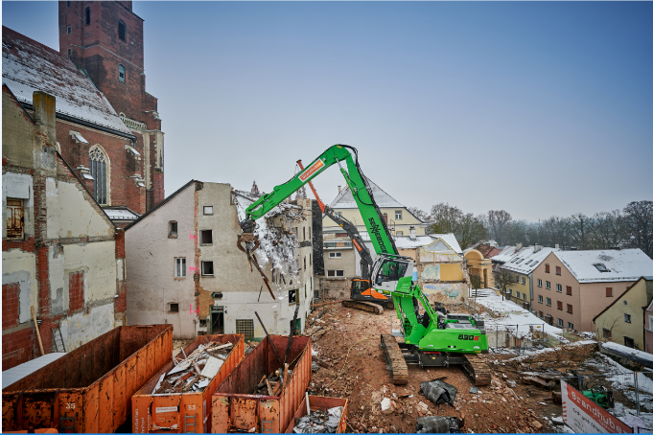

Even the church seems impressed - SENNEBOGEN 830 demolition effortlessly brings the chimney to the ground at a height of 15 meters.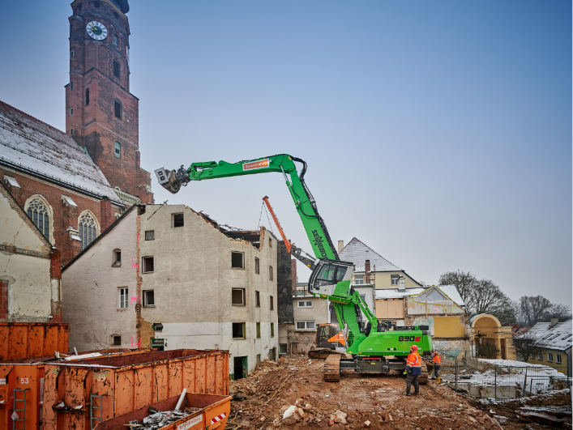

The working area can be conveniently monitored with the SENNEBOGEN 830 demolition machine: the 30° tilting and elevating cab allows operators to work comfortably and safely