Bild:
Editor Autor: Jennifer Bortmes
Location Ort: Straubing, Deutschland
Date Datum: 24.11.2022

Quickly removing an oil trace: Telehandler supports fire brigade

In Straubing, an oil trace several kilometers long stretched through the city center and had to be removed as quickly as possible by the local fire brigade. The bright red telehandler 340 G from SENNEBOGEN in the special fire service equipment with siren and blue light proved to be a useful helper. With its sweeping attachment, it was able to considerably relieve the 9-man crew and thus ensure that the affected roadway was cleared quickly.

Instantly ready for action for efficient removal of the oil trace

If an oil spill occurs, fast and precise action is required. In addition to the threat of environmental pollution, the oil spill also poses great dangers and a high accident potential for road users. To prevent the oil from spreading and seeping into the groundwater and soil, oil binding agents are spread on the affected areas and worked in with brooms. The bound oil is then taken up again and disposed of. In the latter task, the SENNEBOGEN 340 G telehandler was able to demonstrate its capabilities. By means of the hydraulic quick-change system, the machine was converted to the sweeping attachment and ready for use in no time at all. The applied binding agent was picked up by the sweeping attachment and the residue was removed efficiently and quickly. For more severe cases, where it is not a drop-like but a thick, continuous oil trail, the telehandler is equipped with a “Öltiger" at the rear, which can be used to spread the binding agent onto the contaminated roadway.

Significant savings in time and personnel costs

A major advantage of using the telehandler is the considerable saving in human and time resources: thanks to the machine, both the number of operating emergency personnel and the deployment time could be more than halved. The use of the sweeping attachment eliminates the tiresome task of brushing up the binding agent with a hand broom. Whereas 20 to 25 emergency personnel were previously required to remove an oil trace, only 9 people had to be deployed here. The operating time was reduced by at least two hours to half the time usually required. During an incident such as an oil trace cleanup, it is important to disrupt traffic as little as possible. Thanks to the compact dimensions of the telehandler, little space is taken up during operations, and even confined areas can be reached with ease by the machine. The telehandler's cab, which can be raised to an eye-level of up to 4.10 m, offering the operator an optimum 360° panoramic view of the entire working environment, was particularly convincing. Especially in terms of safety, the cab plays a crucial role: "The high position not only gives us a perfect view of the attachment, but also of the entire working environment. This increases safety and precision enormously during our operations," says the team.

Special equipment for the fire brigade with various attachments

In addition to operations such as oil spill cleanup or disaster relief, the telehandler is also used for everyday logistics and transport tasks. The machine is designed to meet the special needs of the fire brigade and, thanks to its robust construction, it is suitable for demanding continuous operation. In addition to blue lights, a siren, and the specific paintwork and decals, the fire brigade also has a wide variety of attachments such as a shovel, shovel with tongs, and a lifting fork. These can be changed quickly and easily at the push of a button for a wide range of applications and thus allow a clean and efficient work flow - a perfect addition to the fleet of the Straubing fire brigade.

Captions:

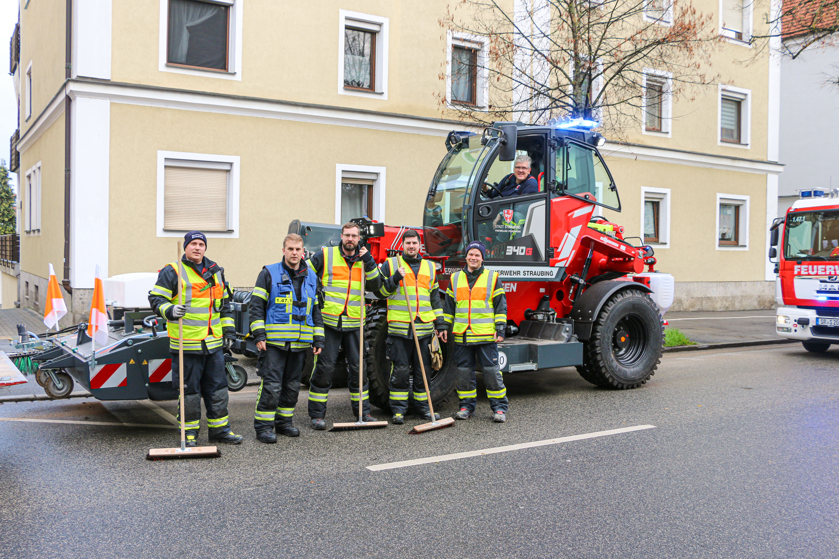
Thanks to the telehandler, the fire brigade was able to finish the job twice as fast – from left: Hennek Patrik, Rosenhammer Michael, Wild Thomas, Ruber Alexander, Schwarz Marius and Englberger Reinhard

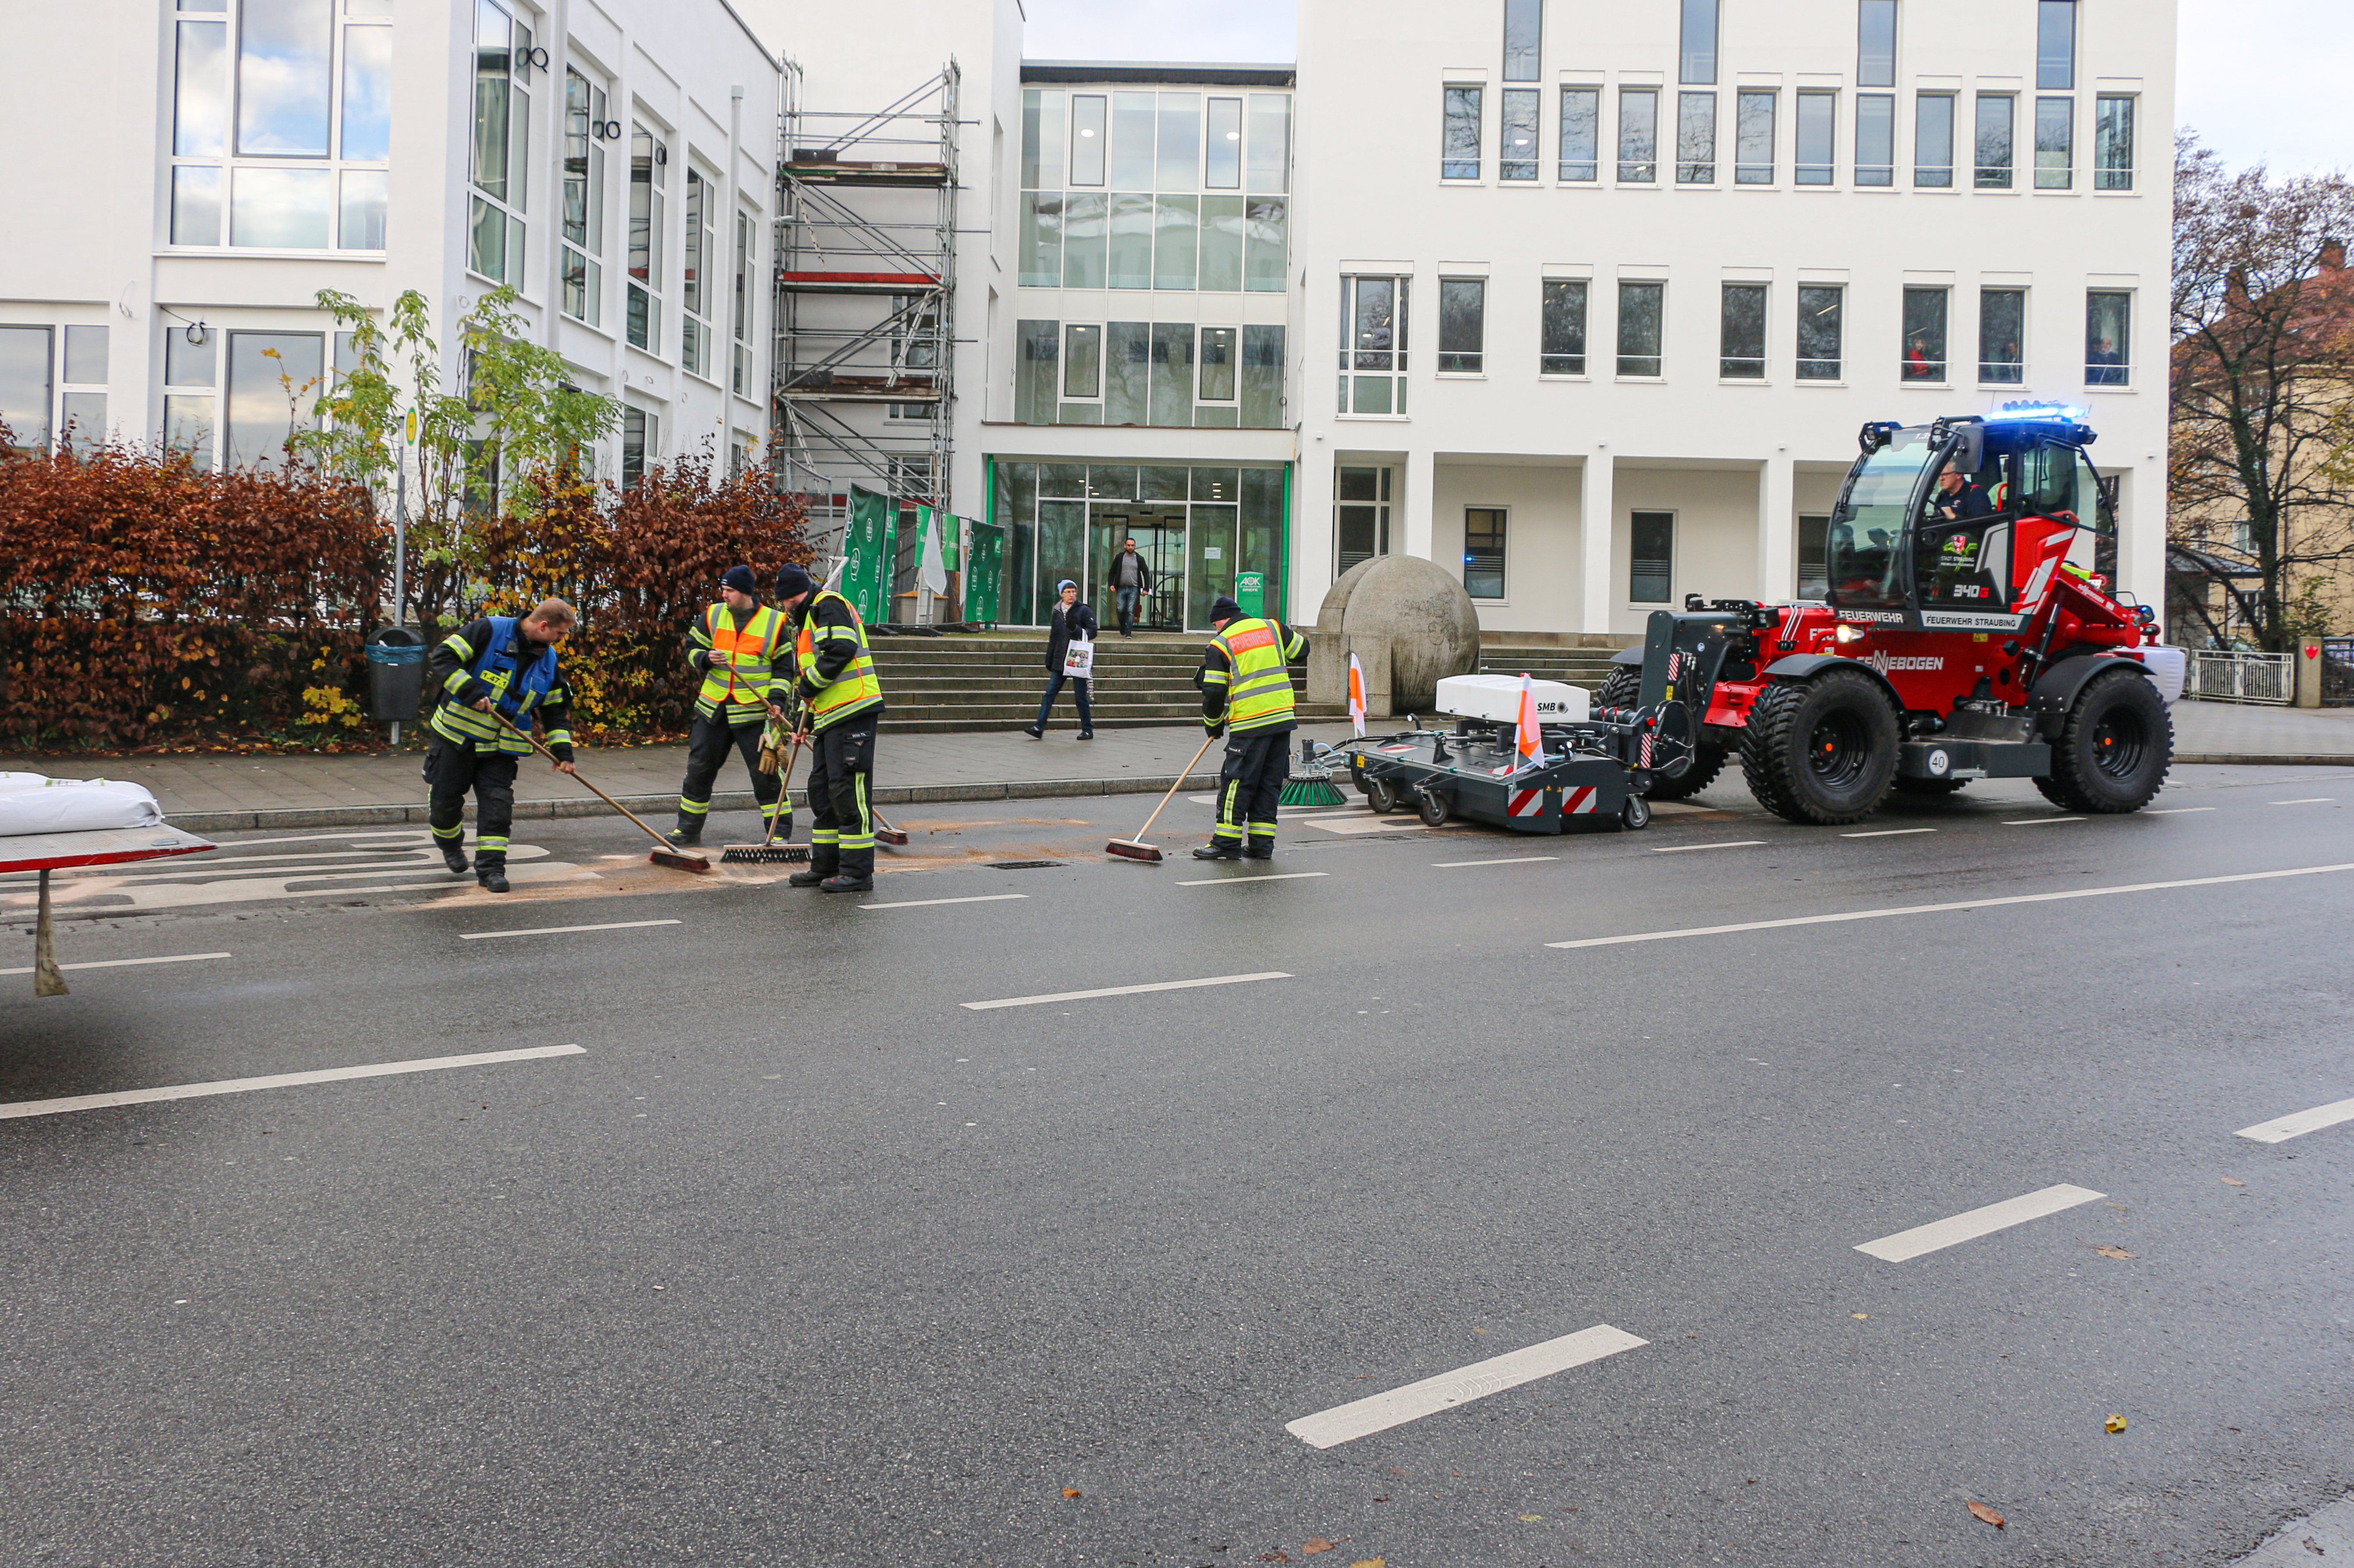
After the fire brigade has spread the oil binding agent on the road and worked it in, the telehandler with sweeping attachment quickly picked it up again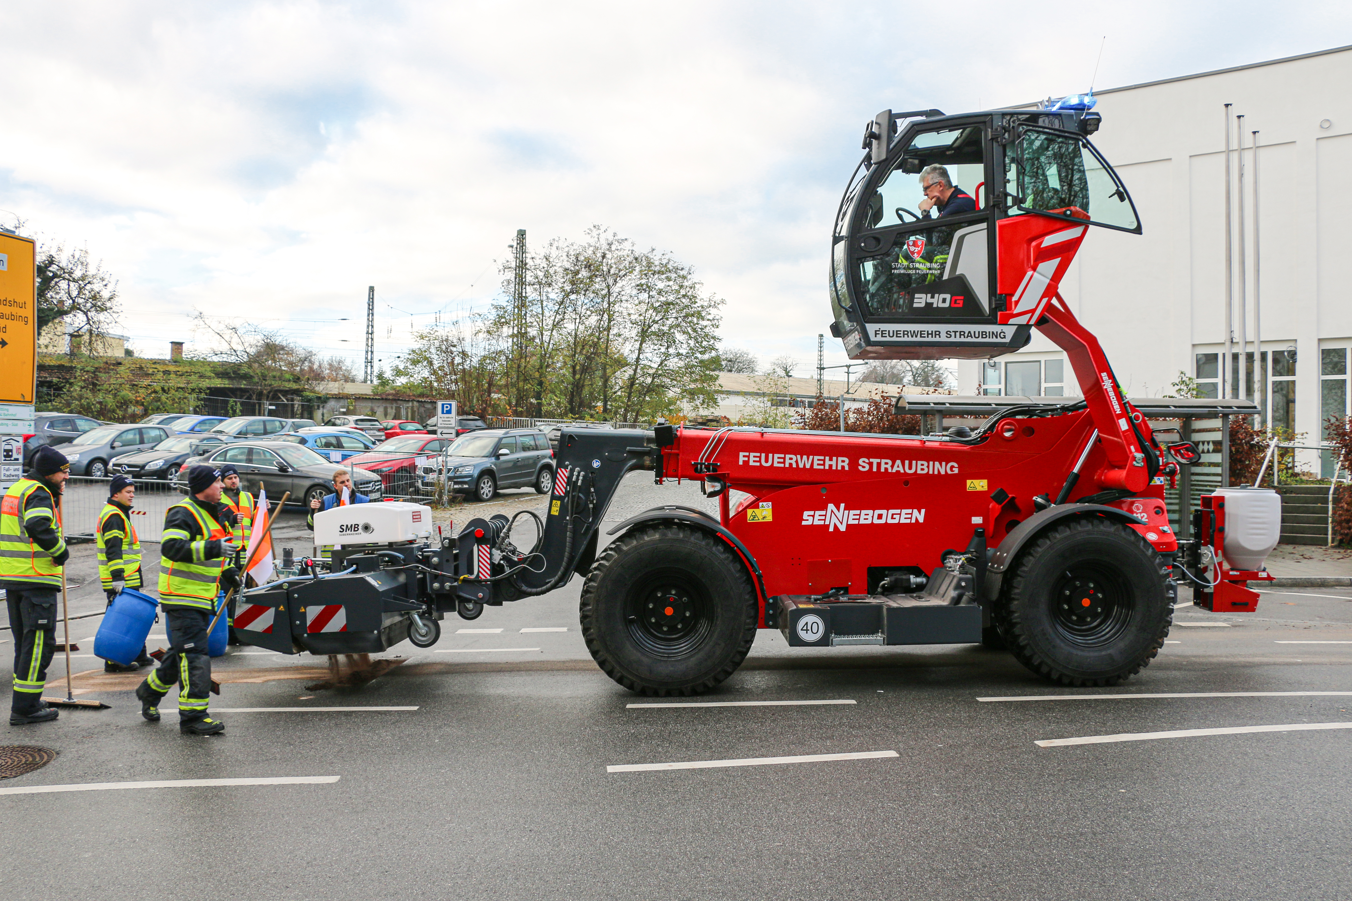
Thanks to the elevating cab, the operator keeps a perfect view of the attachment and the working environment
