Bild:
Editor Autor: Jennifer Bortmes
Location Ort: Longyearbyen, Spitzbergen
Date Datum: 18.10.2023

Recycling under the northern lights: Waste management company on Spitsbergen relies on robust recycling machine

Icy cold with temperatures as low as -20 degrees, surrounded by glaciers, fjords and the northern lights. Spitsbergen is one of the northernmost places on earth, only 1,300 km from the North Pole. Here, the SENNEBOGEN material handler 817 E works in recycling operations under particularly challenging conditions. Despite the extreme weather and the Arctic climate, the 18-tonner reliably supports the Longyearbyen Miljostasjon waste management company in disposing of 2,000 t of waste a year. The machine was sold and delivered by local service partner Volvo Maskin AS.

Waste disposal at extreme sub-zero temperatures

In the Arctic Ocean, halfway between Norway and the North Pole, lies the archipelago of Spitsbergen. Characterised by its pristine landscape and isolated location, it is a central point for mining, coal mining and numerous research stations. Around 2,300 people live in the largest municipality Longyearbyen. It is home to the municipal waste management company Longyearbyen Miljostasjon, which has been in operation since the permanent settlement in the 20th century. With the commissioning of a new building in October 2022, 2,000 t of household and commercial waste is loaded, sorted, packed and exported every year. Especially in the summer months, the volume of waste increases due to the arrival of up to 5,000 cruise tourists. At this point, the staff at the recycling plant is increased from two to four employees to cope with the additional volume of waste from the cruise ships.

The building of the waste management company is divided into two areas. In the front, public section, residents unload their waste, which is first collected and sorted. In the rear part of the building, all the island's household and commercial waste is disposed of. This is where the material handler 817 E from SENNEBOGEN comes into action, equipped with a 500 litre sorting grab and a reach of 9 m to feed the waste to a shredder. After a short sorting line, the material is pressed, foiled and loaded into containers. Finally, it is shipped to a waste incineration plant on the mainland for further processing.

Compact, fast and reliable machine convinces at sorting and loading work

Before purchasing the SENNEBOGEN 817 E material handler, the waste management company used a wheel loader for sorting and loading tasks. However, the space required for manoeuvring and loading the shredder, as well as poor visibility, made daily work difficult. Due to the new building and the changed space conditions in the hall, different working heights were possible - a machine with more reach was required. Investing in the manoeuvrable 817 E material handling machine proved to be the perfect decision. The direct, electric control ensures fast sorting and loading, while the machine's compact dimensions make it easy to move around the hall. The additional customised sliding blade attached to the undercarriage with 4-point stabilizers helps to keep the working environment clean and prevents material from freezing to the ground. The operators were particularly impressed by the elevating cab, which provides an unrestricted view of the entire working area.
The company is completely satisfied: "The 817 E is the ideal machine for our business and has exceeded all our expectations."

Captions:
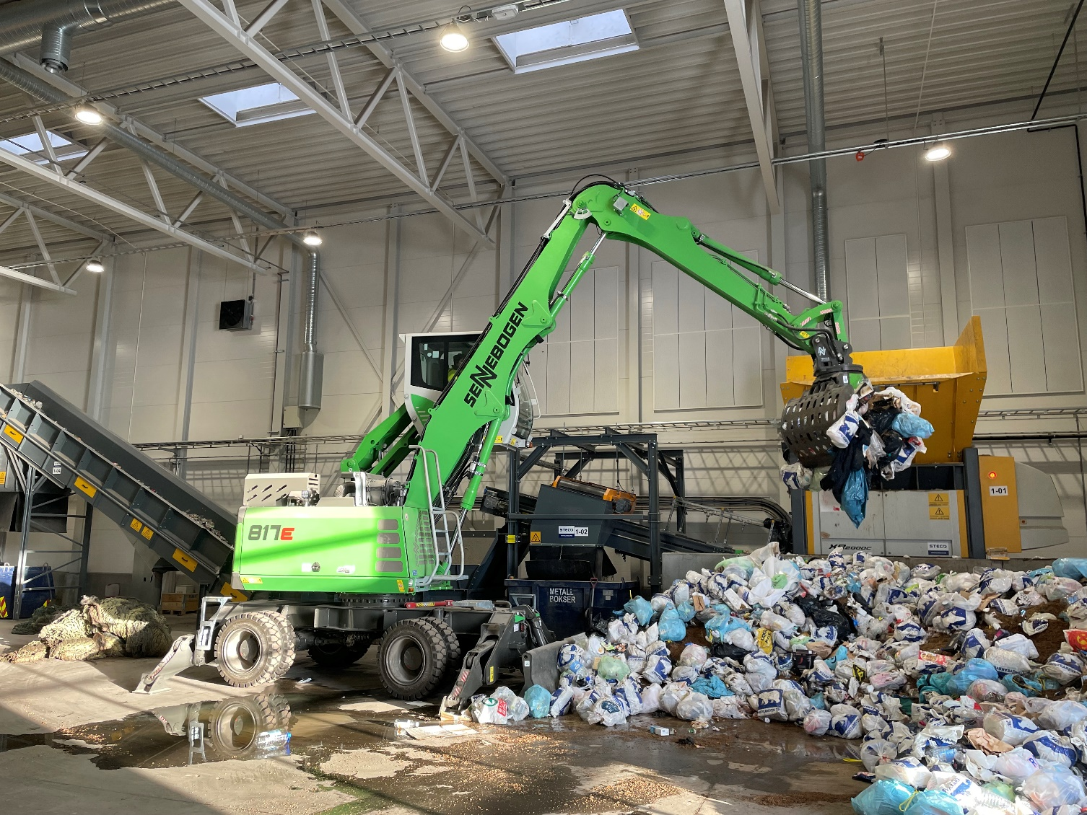

The SENNEBOGEN 817 E scores with its compact dimensions in indoor use

