Bild:
Editor Autor: Andrea Heinrich-Jobst
Location Ort: Straubing, Deutschland
Date Datum: 23.03.2023

Building demolition in only 2 days with 45 t demolition excavator

As in many cities, there is a permanent need for new parking spaces in Straubing's city centre. Since dense development already prevails, free spaces are rare. Next to the railway station site was a warehouse silo that was no longer in use, which has now been dismantled piece by piece by the SENNNEBOGEN demolition excavator 830 E and the demolition company PLANNERER.
The machine, which had been in use as a rental machine from the SENNEBOGEN rental fleet of the SENNEBOGEN sales company, was equipped with a fully hydraulic quick-change system and demolition tongs to carry out controlled dismantling.

Rapid dismantling possible due to fast work performance

When new things are to be built, old things have to give way. In this case, a new multi-storey car park that can be used by the surrounding companies and station guests.
The SENNEBOGEN 830 E demolition excavator is a reliable partner that can carry out building demolition quickly and efficiently. In total, the SENNEBOGEN machine was in demolition use for two days.
For the work in Straubing's city centre, the PLANNERER company used a SENNEBOGEN rental machine, which was able to convince with many features.

Because blasting or even the classic wrecking ball cannot be used everywhere without problems, the SENNEBOGEN demolition excavators offer many advantages - especially for demanding demolition work in confined spaces. In addition, the targeted deconstruction of an object can contribute to sustainability by recycling demolition materials such as bricks, metals and wood through innovative technology.

Fast work and sensitivity of the SENNEBOGEN 830 E

A powerful machine is of great importance in the demolition sector. After all, the work should be done quickly and efficiently and space should be created quickly for the further use of the site.
Another issue is safety at work. The SENNENBOGEN 830 E is equipped with a telescopic crawler track and offers optimal stability, especially on a backfilled demolition plateau.
The small transport width also makes it easy to move the machine to the next job site.
The operators present at the demolition site in Straubing were impressed by the machine's sensitivity and how precisely and quickly it can be operated. The spacious cabin offers plenty of room for relaxed working. Equipped with the elevating Maxcab, which can also be tilted up to 30°, the operator has a clear view of the working area.

After the two days in use in Straubing's city centre, the machine could be moved on to its next assignment.

The demolition company PLANNERER GmbH has been a professional in demolition for 30 years. The company from the northern Upper Palatinate offers its services throughout Germany.

Photo caption:

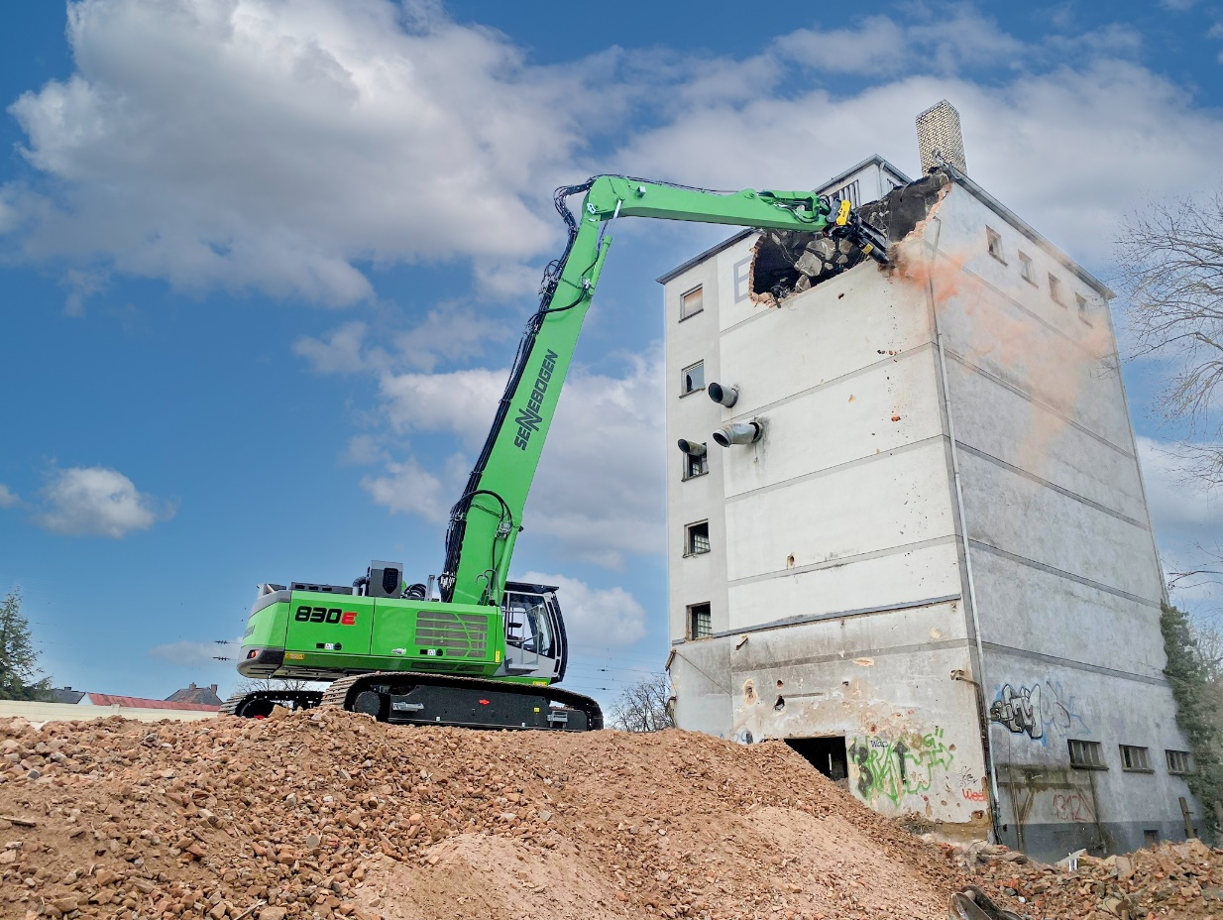
SENNEBOGEN 830 E during the demolition of the warehouse building in Straubing city center.
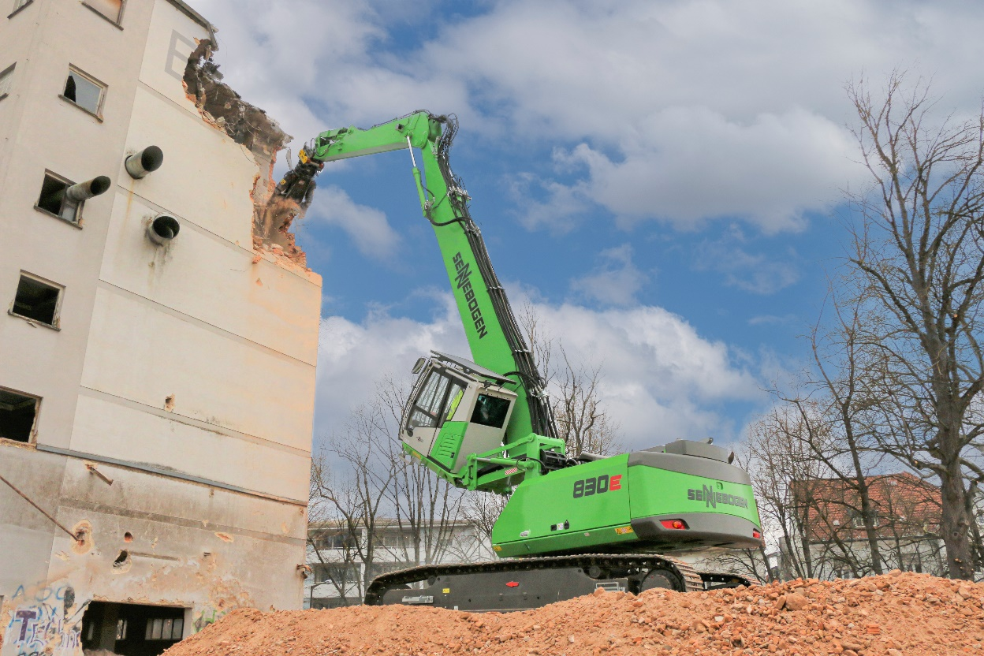
The cab, which can be lifted up to and tilt to 30°, offers an optimal view of the work area and makes work much easier.

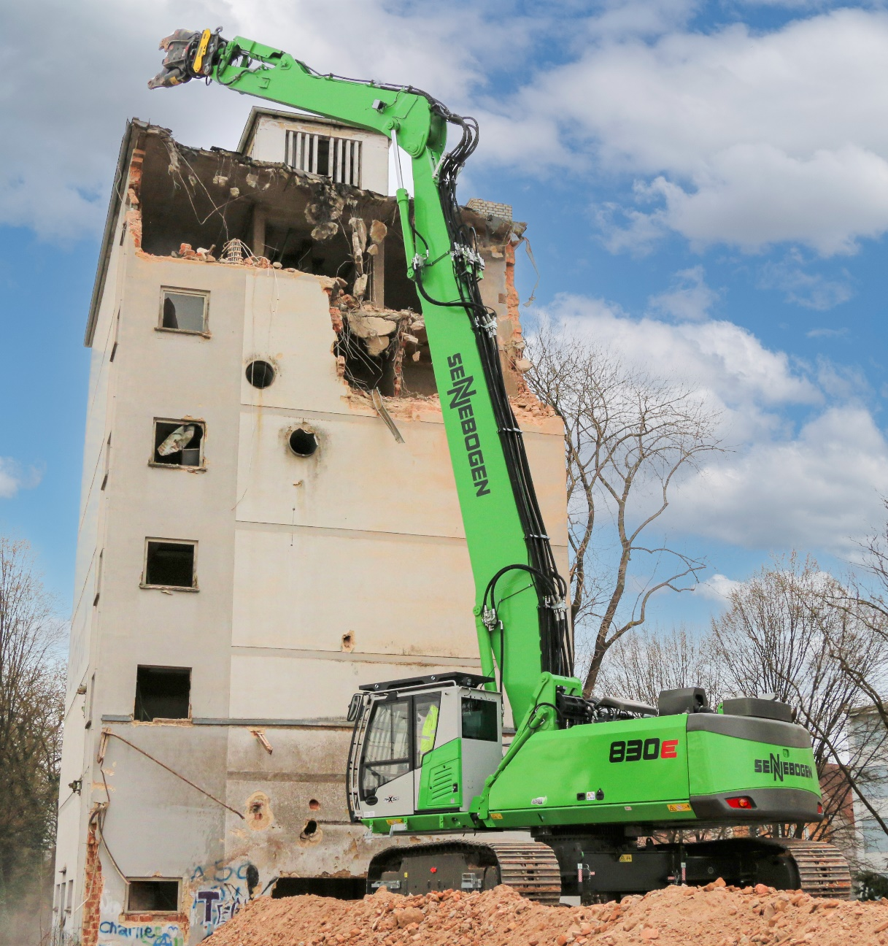

The long reach of up to 18 m bolt height enables optimal work even with high demolition objects.
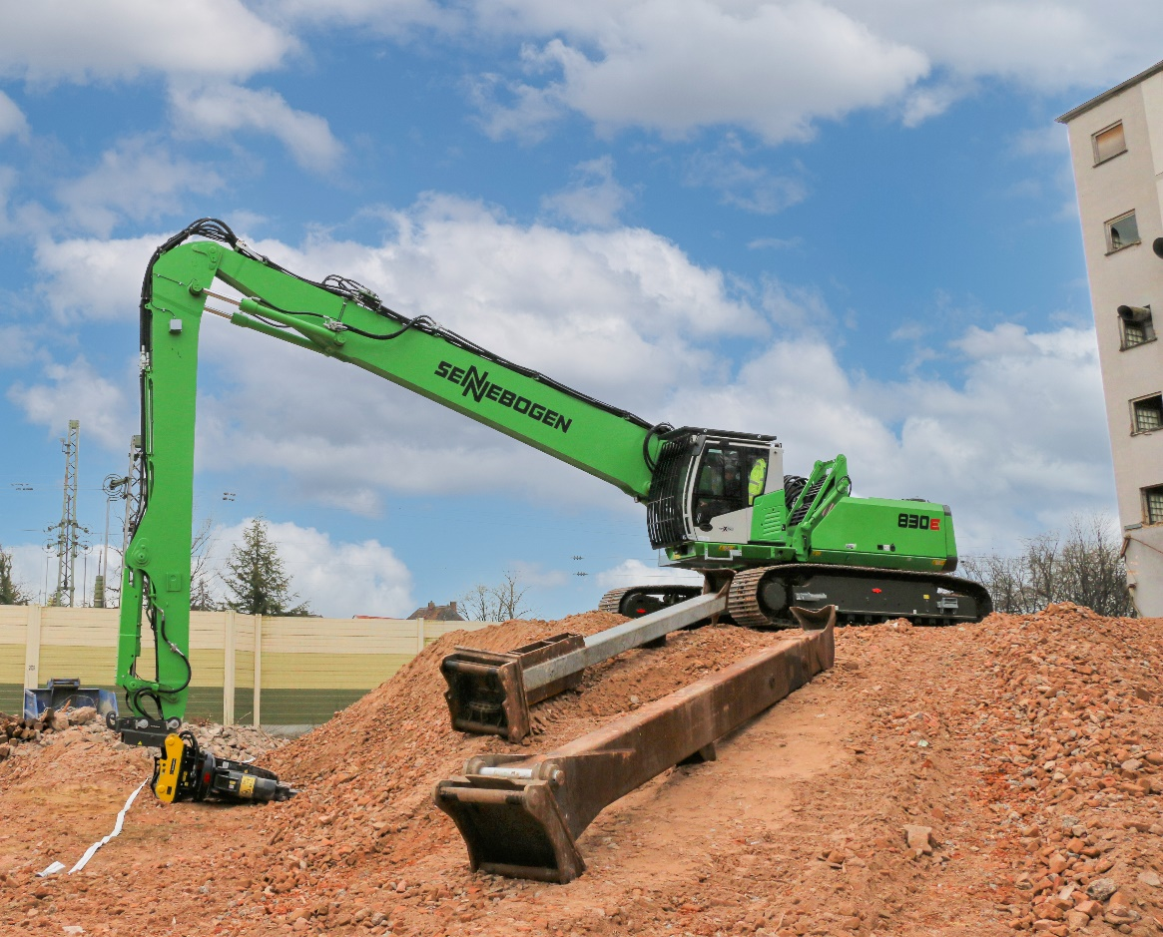

The quick change of equipment tools thanks to the optional fully hydraulic quick-change system can be done conveniently from the cab.

