Bild:
Editor Autor: Andrea Heinrich-Jobst
Location Ort: Straubing, Deutschland
Date Datum: 24.08.2023

Selective deconstruction of car dealership in Regensburg

A conversion is always an exciting thing. A large multi-brand car dealership in Regensburg is being rebuilt and modernized. This required gutting and demolition of the front part of the building to make room for the dealership's new variety of brands.
The company Metz Erdbau GmbH from Schwandorf chose the SENNEBOGEN 830 Demolition from the fleet of the SENNEBOGEN sales company with the 2-part equipment for the work.

In the middle of a residential area, the 830 E is just the right tool here. The machine's innovative SENNEBOGEN technology and performance offer the demolition company many advantages: "With its sensitivity, it feels like the machine grab is my hand, able to grip the individual materials directly with my fingers," says machine operator Oli.
The two-piece equipment enables precise work at lofty heights. The attachments and grabs can be changed individually and depending on the work application via quick coupler. The sorting grab, which can be easily and conveniently coupled from the cab at the push of a button, can be used in between to tidy up the job site and pre-sort the demolition debris for recycling. Thus, a variety of tasks can be completed with just one machine, saving time and costs.

Saftety first: The overriding motto on a demolition site.

The elevating and 30 ° tilting cab provides a perfect view of the upper building elements. This allows the heavy concrete walls of the top floor to be cut through with the demolition shears almost at eye level so that they do not thunder to the ground in their entirety. The heavy work at the height of the top floor requires the highest level of safety for the machinery and the team. A demolition excavator that has to handle heavy work at high reach needs a large stand width, which is up to 4.5 m on the 830 E, achieved by telescopic crawler tracks.

But the SENNEBOGEN machine also scores points when it comes to service. The service points are clearly arranged and the specially developed SENNEBOGEN lubricants SENlube and SENprotect are perfectly matched to the machines. Their use saves fuel and maintenance costs and prevents wear.

All-round service for demolition projects

The SENNEBOGEN rental park makes it possible to rent machines on a medium or long-term basis. Like the company Metz Erdbau GmbH in this case, you benefit from a low investment and at the same time top-maintained machines directly from the manufacturer. There is also the possibility to redeem the rental machine by purchase option. The Sennebogen demolition expert will be happy to advise you on the selection of attachments or equipment with a quick-change system.

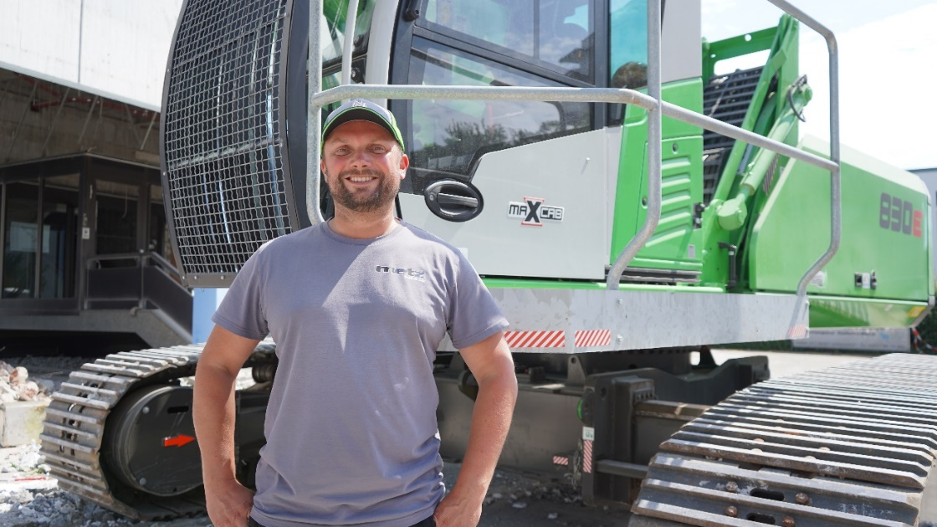
Machine operator Oli is proud of his 830 E.

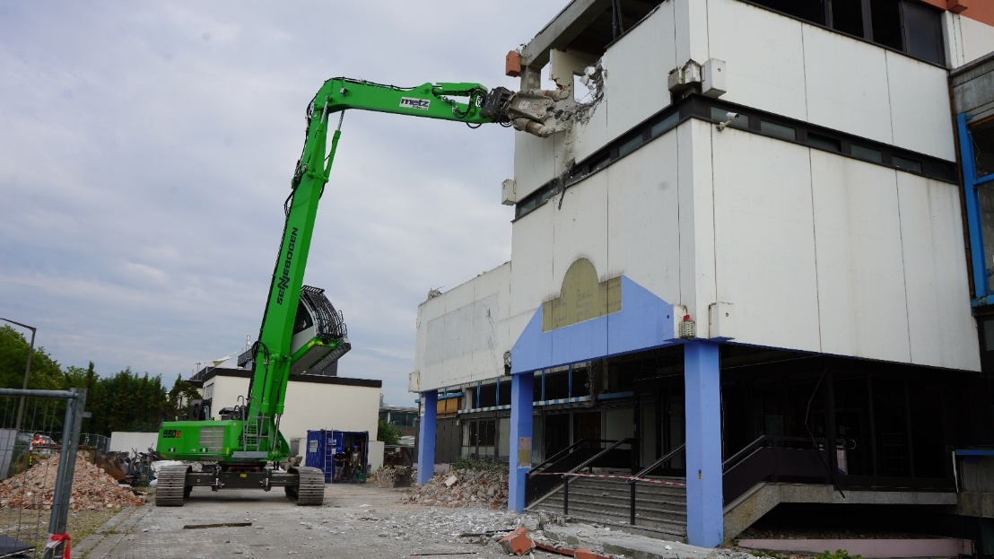
Easy access to the upper demolition objects with the two-piece equipment.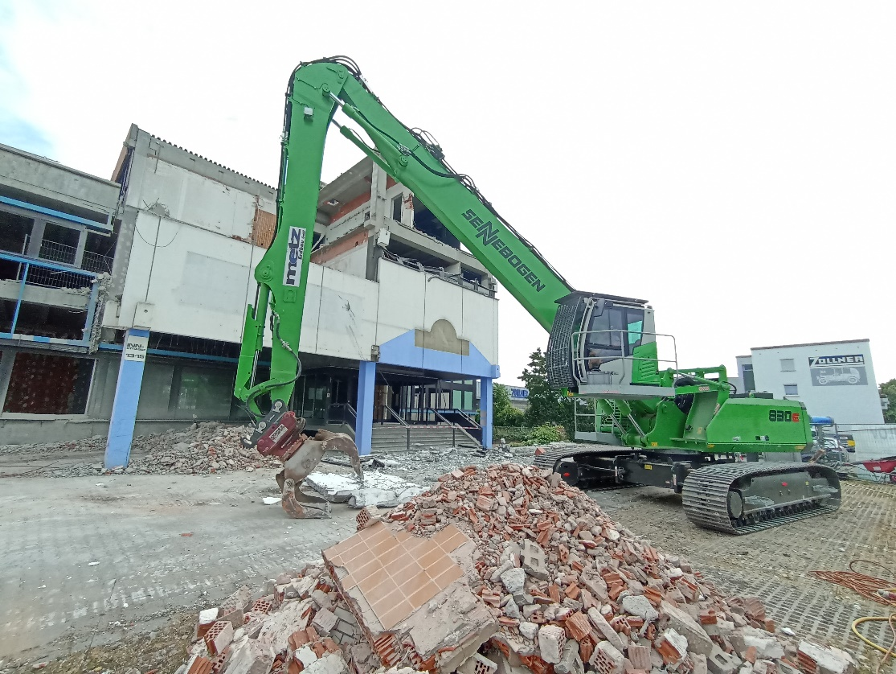
Cleaning up the demolition elements with the grab tongs.

