New 26 t recycling material handler: SENNEBOGEN 826 G-Series
SENNEBOGEN material handlers have been shaping the machine landscape in waste recycling for years. Now the introduction of the powerful and versatile 826 G-series expands the product portfolio and sets new standards in efficiency and reliability.
Optimal solution for waste recycling applications
The new 826 G-series machine is the latest addition to the SENNEBOGEN recycling family. With an impressive reach of 13 meters and an operating weight of 26 to 28 tons, depending on the equipment variant, the machine is the ideal solution for waste recycling, scrap, and timber applications. Robust components and intelligent machine design ensure that the machine retains its value over the long term, even during demanding continuous operation in challenging working environments such as extreme weather, heat, or high dust levels. A large system performance paired with further optimized hydraulics also ensures outstanding efficiency.
Delicate sorting work at the recycling or scrap yard
Whether loading or sorting – the new 826 G proves to be a universal all-rounder in the recycling or scrap yard with its wide range of different equipment options. The 5 undercarriage variants are also particularly versatile in this machine class. In addition, the modular system offers a wide variety of solutions, whether with orange peel, clamshell, sorting grab or magnet – the new machine can be used to implement a wide variety of application-specific solutions. Thanks to sophisticated, state-of-the-art technology and the consistently further developed machine concept, the 826 G, another representative of the 6th machine generation, impresses with its excellent response behaviour and makes sensitive sorting work in the recycling or scrap yard child's play.
Improved visibility and safety
The new cab elevation not only provides the driver with a great deal more viewing height for maximum safety and visibility. Thanks to its extremely robust design, the Maxcab, which can be raised by 2.8 meters, also guarantees smooth and fatigue-free work, even when driving at high speeds. The spacious cab is designed to meet the needs of the driver – comfortable, roomy and with well thought-out details. The panoramic window provides an overview of the entire working area and ensures maximum safety when loading and maneuvering. In addition, cameras and numerous other safety features ensure optimum protection for people, the surroundings and the machine and get them safely through the day.
Environmentally friendly and economical handling
The new model lifts an impressive 4.2 tons at a reach of 10.5 meters and can handle a correspondingly large amount of material per work cycle with its robust equipment. Equipped with a 127 kW Stage V diesel engine, the state-of-the-art machine is particularly environmentally friendly and economical.
Easy maintenance and service
The new maintenance concept of the 826 G-series offers clearer and simplified access to service points such as the central lubrication system and the tanks, making day-to-day maintenance easier. The central electrical distributors and electronic modules also make maintenance and service easier and are protected from environmental influences thanks to the large E-box. Other technological innovations also ensure that the overall service intervals have been extended once again.
World premiere at IFAT 2024
The new 826 G-Series machine celebrates its world premiere at IFAT 2024. Be there and experience the machine live at the more than 400 m² SENNEBOGEN stand.

Captions:
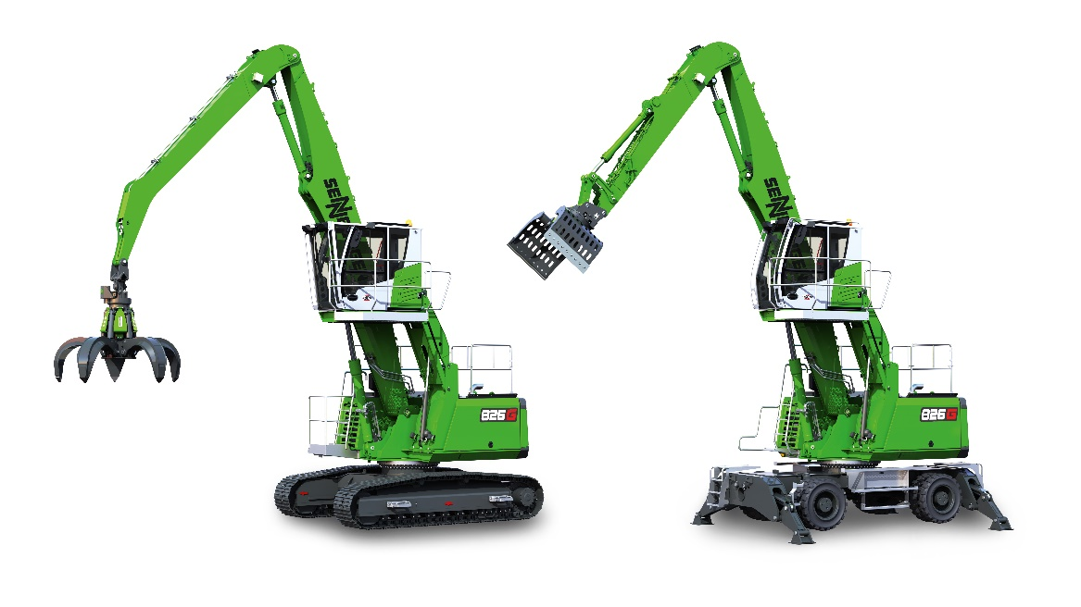
The newly developed SENNEBOGEN 826 G impresses with increased performance and lower fuel consumption.
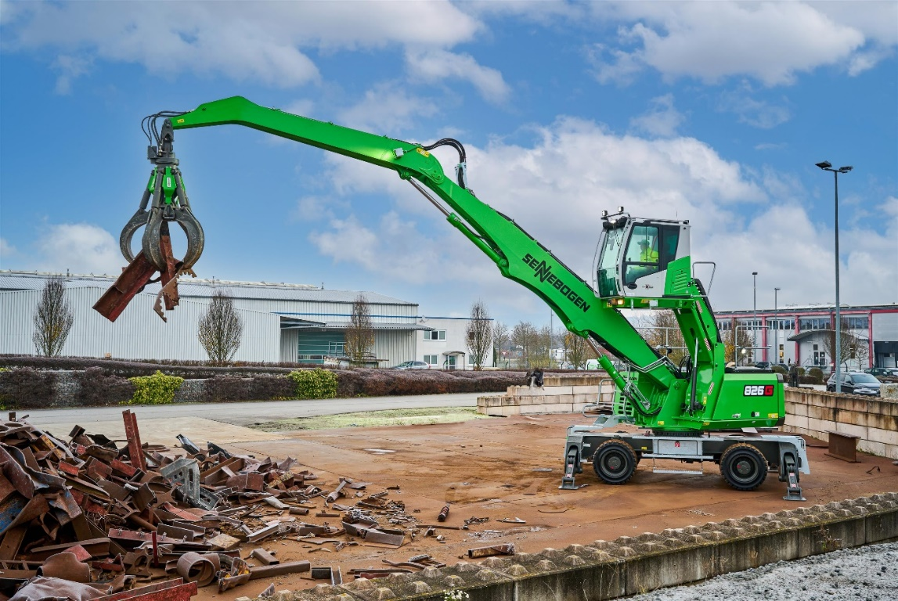
The new 826 G scores with a reach of 13 meters in both scrap handling and waste recycling.

