Bild:
Editor Autor: Sandra Hartl
Location Ort: Schkopau, Deutschland
Date Datum: 11.2023

Focus on multifunctionality – use of a telehandler in a biogas plant

Biogas plants play a decisive role in sustainable energy production. The processing of organic materials not only produces green electricity, but also valuable fertilizer. The efficient operation of biogas plants depends on the smooth running of the processes. This is where the use of multifunctional telehandlers comes in to optimize processes and increase efficiency.

The disposal of biogenic waste and the recovery of the resulting energy is the core business of BioCycling as part of the Veolia group of companies in Schkopau, Germany. Hospitals, supermarkets and canteen kitchens in a catchment area of up to 100 kilometers supply the company several times a day with food waste or expired goods that have to be removed from sale. The company generates around two thirds of its turnover from waste disposal, while one third comes from energy recovery through waste recycling.

Multifunctionality as a key concept: telehandler as an all-rounder
In the search for an efficient and flexible machine, BioCycling decided to use a SENNEBOGEN 340 G telescopic handler. Multifunctionality was a key factor for the operator. As an all-rounder, the 340 G not only offers maximum lifting height and reach for use in the biogas plant, but also scores points with its range of attachments. With its precise controls, it enables loads to be moved effortlessly in a wide range of applications.

The multifunctionality of the telehandler in particular was a decisive purchase criterion for BioCycling. "We can utilize this machine to the maximum thanks to the various attachments. No other competitor product can do that. This purchase was therefore the best decision from an economic point of view," emphasizes Dr. Steffen Bieler, operating manager.

Fields of application and useful attachments for telehandlers in biogas plants:
- Bucket: BioCycling uses a 2 m³ bucket as the main attachment for loading biomass.
- Pallet fork: A pallet fork is used to load pallets with food into the shredder provided for this purpose. The hydraulics are designed in such a way that the pallet can be lifted and the attachment can be turned so that the pallets can be tipped. To ensure work safety, the driver can use the cab elevation to keep an eye on his work area and the shredder.
- Man basket: In the past, cherry pickers had to be hired for regular maintenance or inspection work in particular. With the new telehandler and man basket, this work can now be carried out more cost and time efficiently.
- Lifting hook: In some cases in the past, it was also necessary to hire a mobile crane, for example to change the agitators, which have to be replaced from time to time. A specially designed crane hook is now used for such operations.

Thanks to the integrated quick-change system, attachments can be swapped easily and in the shortest possible time. "With the new telehandler, we combine various applications of our daily work in one machine. This saves us enormous rental costs and, above all, time, as we can use our machine when we need it," says Dr. Bieler.

Cab elevation for telehandlers ensures work safety
Before the decision was made to purchase the 340 G from SENNEBOGEN, most of the work was carried out using wheel loaders. In order to demonstrate the advantages of the telehandler concept, the 340 G was tested in advance in cooperation with SENNEBOGEN sales and service partner Günsel Fördertechnik. "The 340 G is much more compact and yet still robust. The cab elevation offers our operator a much better view and therefore a safer feeling when working. With our wheel loaders, you can sometimes get in the way on our often confined company premises. That won't happen to us with our new telehandler," says operating manager Dr. Bieler.

Caption:
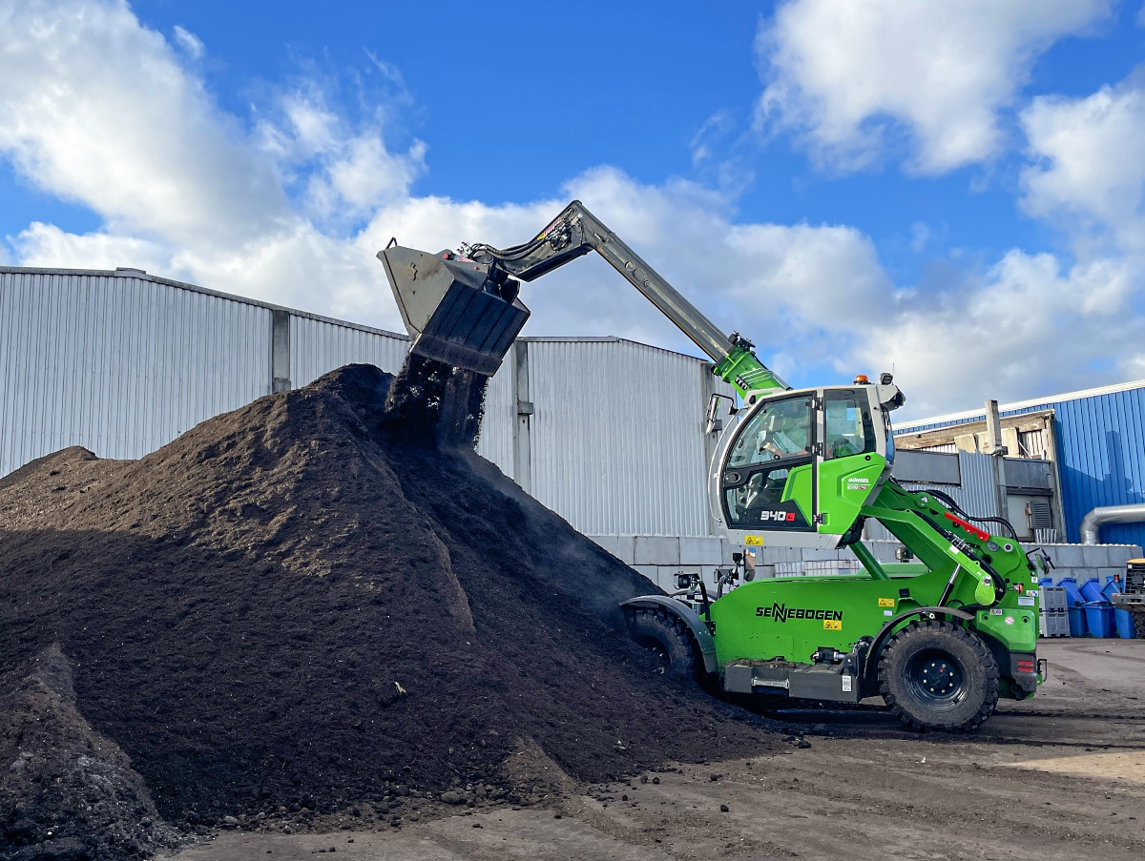
Telehandler 340 G loading biomass with 2 m³ bucket
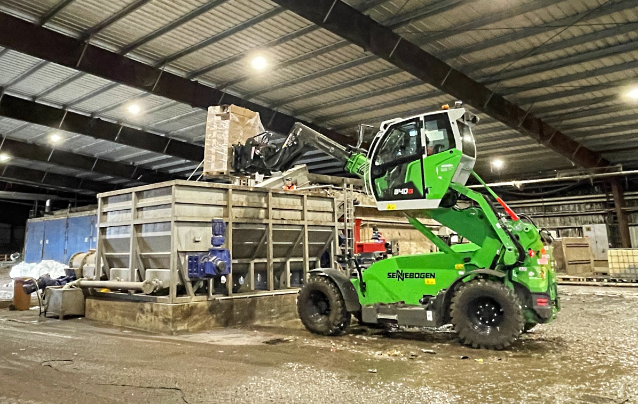
Best view of the work area: tipping pallets with hydraulic pallet forks

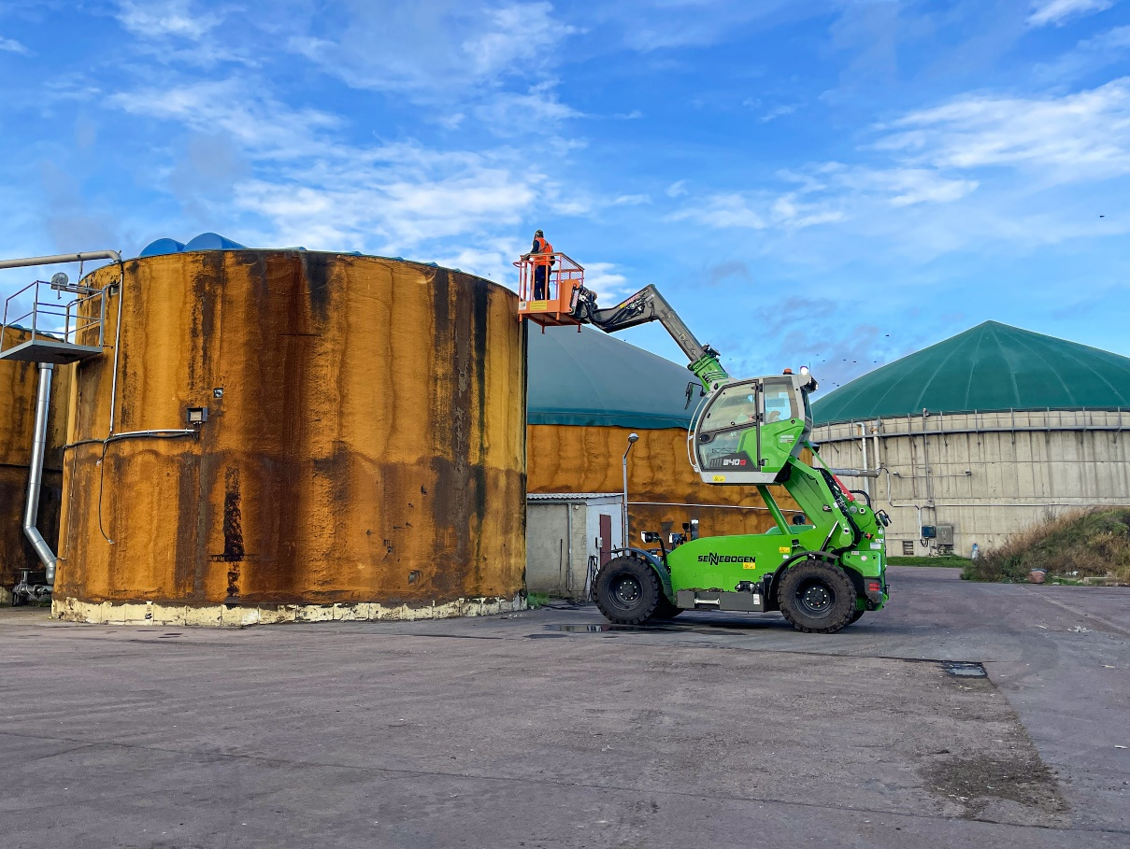
Maintenance work made easy with telehandler and man basket 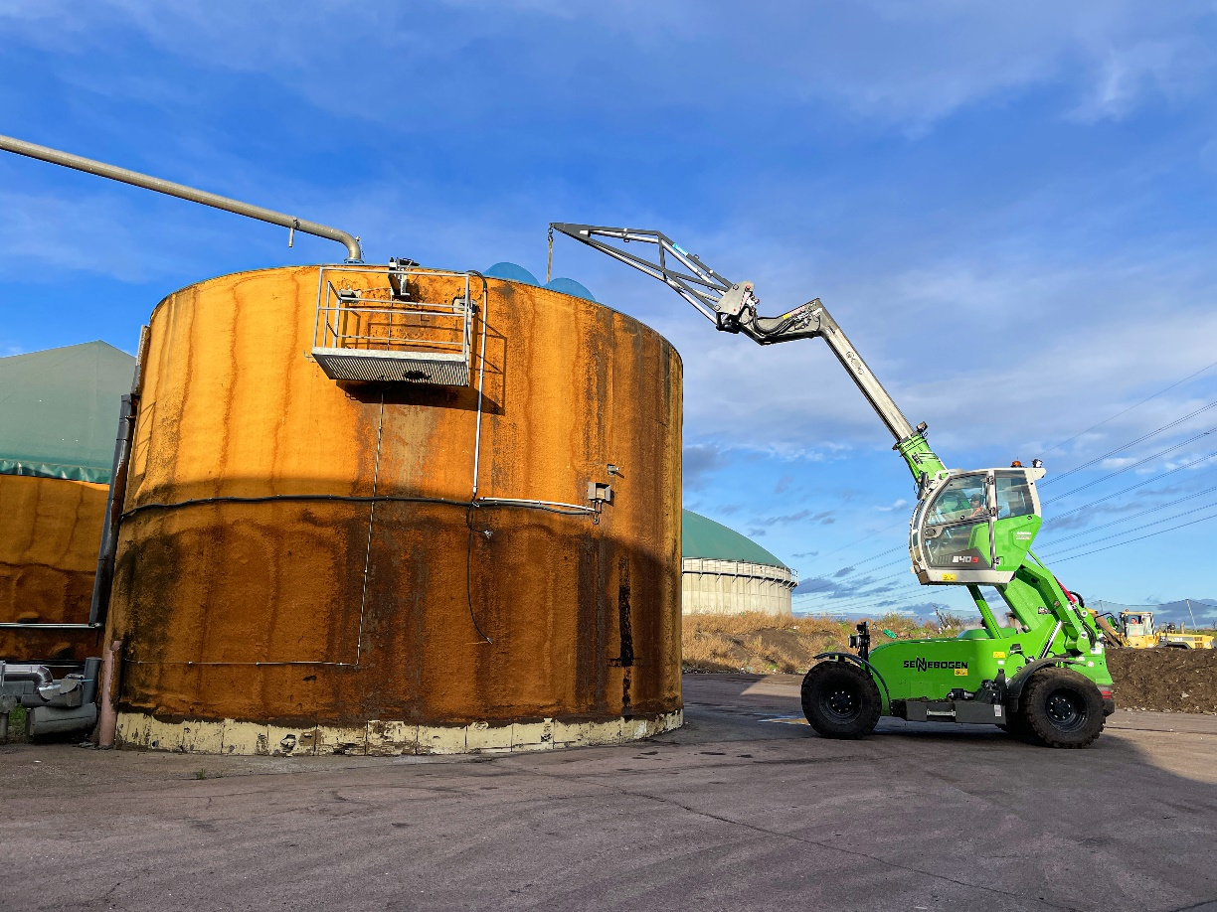
340 G with lifting hook for replacing agitators in biogas plants

