All-rounder demolition machine: The new SENNEBOGEN 825 E Demolition
Powerful in demolition and dismantling: For years, SENNEBOGEN demolition excavators have been offering solutions for efficient and precise work on tight construction sites and at great heights. Now the 825 E Demolition expands the existing demolition range downwards and celebrates its trade fair premiere at IFAT 2024.
Flexible and fast in use
With an impressive reach of 14 m and outstanding maneuverability, the new introduction effortlessly masters the common challenges of selective demolition. The flexible demolition excavator, which has unique stability thanks to the telescopic wide-track undercarriage, is not only impressive in the selective demolition of buildings using demolition grabs, demolition hammers or pulverizers, but is also ideally suited for sorting tasks. Thanks to its compact dimensions, the powerful new model with an operating weight of 38 t is ideal for use on urban construction sites and in confined spaces. The 825 E Demolition also impresses with its innovative quick-change system: a wide range of attachments, including the demolition hammer, can be used flexibly and easily changed by the driver from the cab within a very short time.
Stable and robust
Safety is guaranteed not only by the stable undercarriage with an overall width of 4.2 m, but also by the unique cab, which can be raised by 2.7 m and tilted by 30 degrees. This allows the driver to work ergonomically, leaning back in the seat with a clear view of the attachment. In addition, the robust construction of the machine and safety features ensure safe working in the demolition area.
Easy transportation and ready for immediate use
Thanks to the hydraulically lowerable counterweight, the transport weight of the 825 E Demolition can be reduced by 10 tons so that the demolition machine can be easily transported without a special permit. There is no need to dismantle the equipment – it can be transported in one piece on a low-loader. In addition, the 825 E Demolition is immediately ready for use without any set-up work.
Trade fair premiere at IFAT 2024
Experience the 825 E Demolition live at the additional demo area in the inner courtyard between halls C5 and C6 as part of the building materials recycling area at IFAT 2024 in Munich.
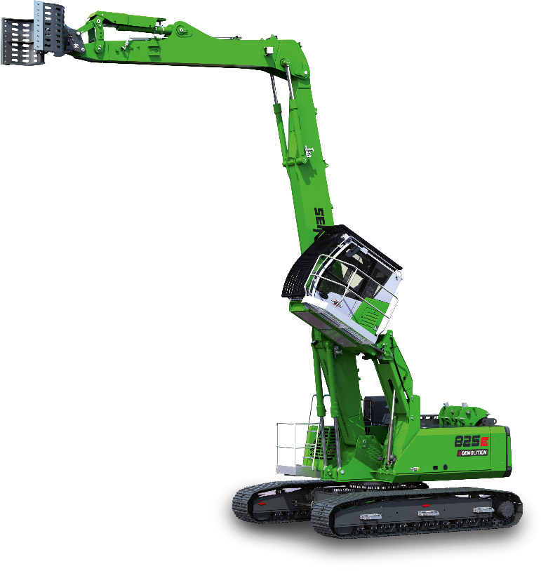
Caption:

The all-rounder machine: perfect for demolition and sorting tasks in confined spaces.

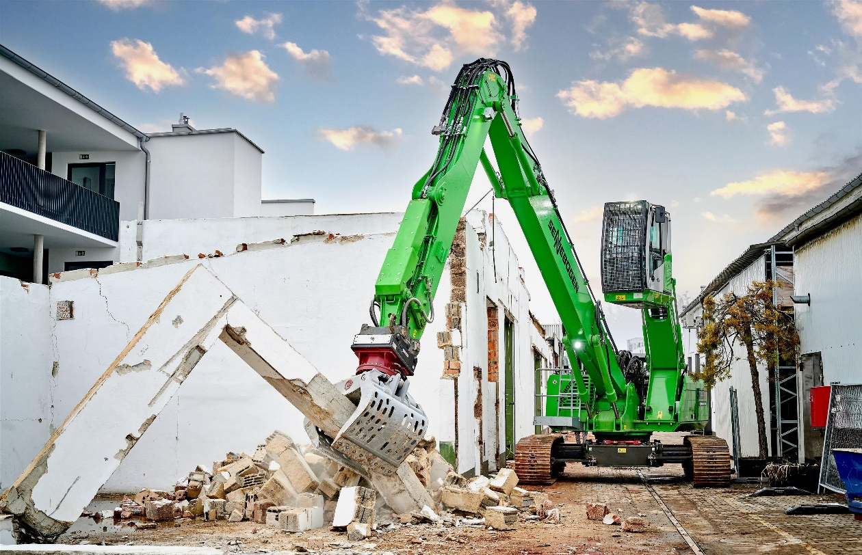

The SENNEBOGEN 825 E Demolition with telescopic crawler undercarriage impresses with maximum stability.

